Week beginning 18th May
Hi all of you!
Once again it was good to have a chat with you all this week.
We are really enjoying hearing about what you have been busy with and thank you for all the brilliant photos you have sent us.
Please continue to check Purple Mash for weekly tasks and use Serial Mash to continue your reading. If you’ve been having trouble accessing Purple Mash visit: https://www.purplemash.com/sch/shaftesbury-e7 and enter your username and password (this is the same details you use during computing lessons). Remember, make sure the school selection is Shaftesbury Primary school. Do not forget to also look at the school’s website for updates on home learning. You can visit: https://www.shaftesburyprimaryschool.co.uk/page/?title=School+Closures&pid=101 alternatively when on the Shaftesbury website visit- Parents- School Closure.
Stay safe
The Y5 team
English:
Storytelling with Vanessa Woolf
Thank you to everyone who listened to the stories. Which story did you enjoy most?
Lady of Stavoren or Freedom bird?
If you did not view the performances, then please follow the links below and watch them before completing the writing tasks.
https://www.youtube.com/watch?v=jsB-8fOLd7Y&t=44s - Lady of Stavoren
https://www.youtube.com/watch?v=SOKEgYTITPA Freedom bird

Writing tasks:
Task 1:
Re-write your favourite story (Lady of Stavoren, Freedom bird ) - what happened in the beginning, middle end?
Summarise your favourite story, remember to write in the past tense.
Write a review of one of the stories giving your opinion to your friend. What did you like? Who was your favourite character?
Illustrate your writing.

Task 2:
https://www.pobble365.com/stampede

Story starter!
“Charge!” he screamed, feeling mighty atop the lead rhinoceros. He jolted with every step they took, the rhino’s feet punching into the baking hot sand, sending up large clouds into the humid air so that he could taste the grains of sand in his parched mouth.
The herd stampeded across the desert sand, focused on reaching their goal…
Can you continue the story?

Question time!
Who is the boy? Where is he from?
What is he doing there?
How has he managed to control the rhinos?
Where are the herd heading? What is their goal?
How do you think rhinos communicate?
Did you know that rhinos are endangered? Why do you think this is?
What do you think makes rhinos unique from other animals?

Sentence challenge!
Fronted adverbials
A fronted adverbial goes at the beginning of a sentence.
It describes the verb in the sentence.
It describes where, when or how.
E.g. At midday, the sun was at its hottest.
After the stampede, the boy felt excited.

Sick sentences!
These sentences are ‘sick’ and need help to get better. Can you help? Could you add an adverb?
The rhino walked across the sand. It was grey. It was big.

Perfect picture!
Imagine you can see through the rhino’s eyes. Draw what you might be able to see.

Maths:
Starters- write down all prime numbers up to 100. Remember prime numbers are only divisible by itself and 1.
Write down factors of : 12, 25, 36, 64, 81, 121
Write down all square numbers up to 12. Remember square numbers are numbers you multiply by itself (2 squared- 2x2 = 4).
This week’s maths is to review knowledge of fractions, decimals and percentages.
Write these percentages as decimals and fractions:
EG. 80% - 0.8 – 80/100 (simplified- 8/10)
75%
16%
54%
97%
6%
25%
7%
87%
50%
10%
30%
Challenge Qs!!!
Q1.
Circle the percentage that is equal to
90% 90.9% 99% 9.9% 9%
Q2.
This model is made with 20 cubes.

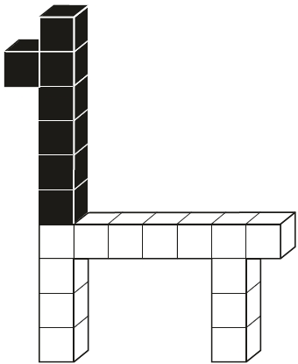
What percentage of the cubes in the model is black?
Q3.
Write these in order of size, starting with the smallest.
0.34 0.7 43%
Smallest

Weekly problem solving puzzle:

Science: Following on from your work on Lifecycles. Draw a diagram and explain the life cycle of an amphibian. Can you think of another life cycle for a different animal?
Look at the stem project:
https://www.stem.org.uk/remote-lessons/key-stage-2
Topic Work – South America
See if you can research the populations of each country in South America. Do larger countries have larger populations? What rivers are there in South America?
PE: Try these Yoga poses.
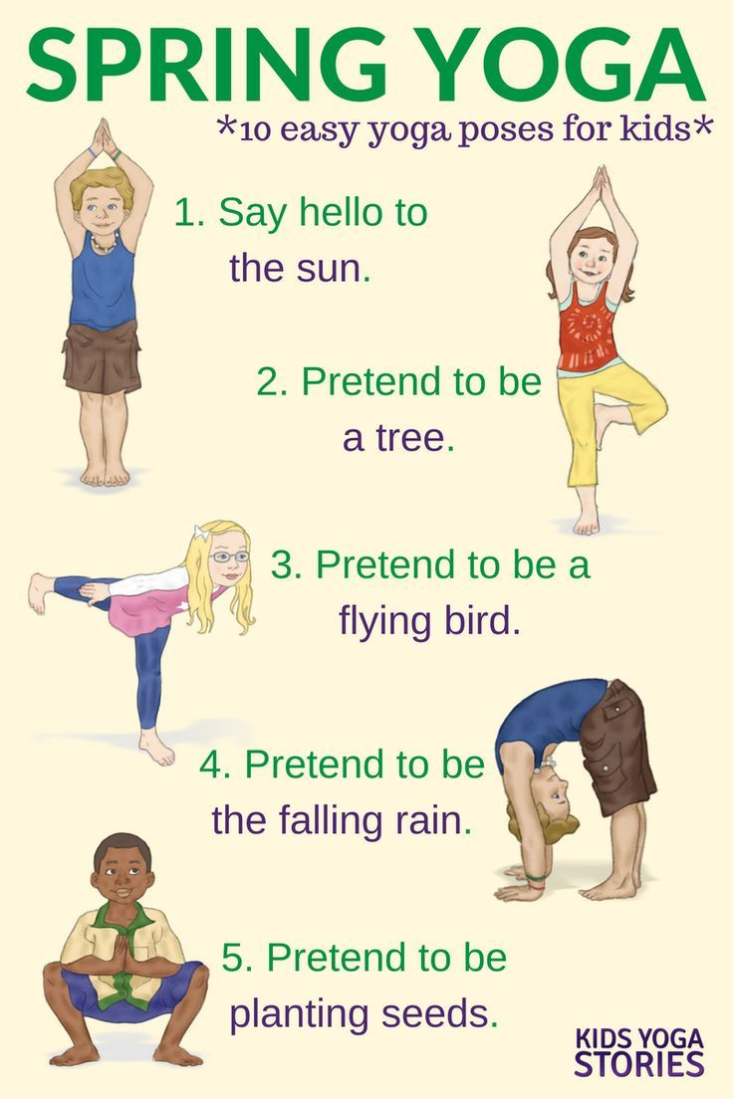
Art:
Make a multicoloured guitar.
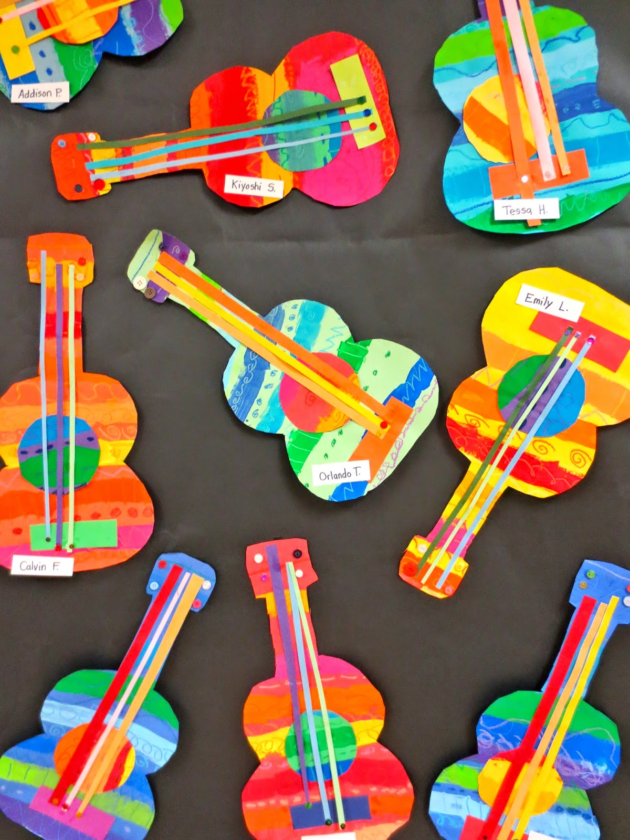

Music:
Find a piece of music that you think fits these different emotions:
- excitement
- joy
- energetic
Why do you think that particular song fits the emotion? Think about the tempo, instruments and dynamics (how loud or quiet).

