The Year Five Newsletter 24/8/20
Hey everyone!
We hope you and your families are well.
Thank you for all your hard work this year. Other than having fun and enjoying the sunshine, please continue to do some home learning over the summer holidays! There are lots of tasks that you can complete on Purple Mash and the school website. Well done for all your dedication towards your learning. Keep up the good work!
Purple Mash: https://www.purplemash.com/sch/shaftesbury-e7 and enter your username and password (this is the same details you use during computing lessons). Remember, make sure the school selection is Shaftesbury Primary school.
There are lots of activities on the school website! You can visit: https://www.shaftesburyprimaryschool.co.uk/page/?title=School+Closures&pid=101 alternatively when on the Shaftesbury website visit- Parents- School Closure.
English
Task 1: Comprehension
Answer these questions on the text:
1. The following characters are ghosts:
a) Celia and Jeremy b) Jeremy and Buzz c) Buzz and Larry
2. The fundamental problem in this story is:
a) Celia and Jeremy fall into the porch and are trapped b) Celia’s parents don’t believe Buzz c) Celia’s parents are not being honest with Celia d) Celia’s parents cannot see ghosts
3. Celia and Jeremy became friends when:
a) Jeremy introduced her to Larry b) Celia found out Jeremy could see ghosts too c) Buzz introduced Celia to Jeremy d) They met at the abandoned house on Quaker Street.
4. Before Celia became Buzz’s friend, Buzz was:
a) Still alive b) Bored c) Lonely
5. Use a dictionary to find the meaning of: commiserated, materialize, congregate and decrepit.
6. Why was Celia’s parents lying to her about Buzz?
7. What kind of impact did Buzz have on Celia?
8. How did Buzz save Celia’s life?
Task 2: Writing
Write a 3-paragraph sequel to this story. What happens next to Celia and Buzz?
Maths
Shapes
A – Fill in the name, number of faces, edges and vertices for each shape.

B – Match the shape to the correct properties.

C – Match the shape to the correct properties.

Shapes reasoning problems:
1.

2.
3.

Science
Life Cycles
Research the life cycle of an elephant. Elephants go through three main stages; what are they? What happens during each of these stages?
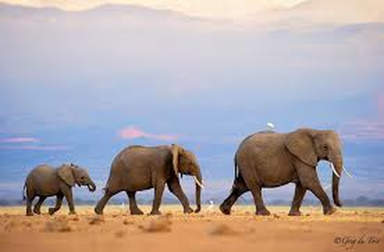
Task: Write 3 paragraphs on the three main stages in an elephant’s life. Draw a diagram underneath!
History
Last week, you looked at some of the great inventions from Victorian era. Today let’s look at some of the important Victorians, one being Mary Seacole who was known for her medical work in the Crimean War.
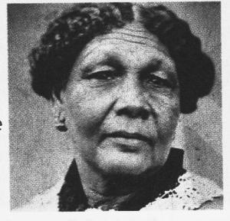
Task – Watch these three short videos on the life of Mary Seacole and summarise the stories.
https://www.bbc.co.uk/teach/class-clips-video/history-ks2-victorians-mary-seacole/zmmmf4j

If you can not access these clips, create a biography on this famous Victorian!

