The Year Six Transition Newsletter – 17th July 2020

Hello Year 6,
We hope you and your families are doing well. To further help you with your transition into secondary school, we have decided to send you some extra learning over your summer holiday. This is to make sure, that despite these extraordinary circumstances, you have the best possible preparation for your new school. Please make sure to work over these packs and record your learning in your learning books or on your computers. You can send your work in by taking pictures and sending them via email or doing the same with the documents you create on your computers. We hope that you are still receiving messages and emails from your new schools. Make sure to attempt every piece of learning they send you as well! We continue to thank you for all the great work you have continued to complete over the last few weeks and we’ll continue to keep checking in and seeing what you are up to.
We will stop updating weekly tasks on Purple Mash from the 17th July. However, make sure to use Serial Mash to continue your reading and comprehension practice.
As well as Purple Mash, we have also been able to give you all access to MyMaths until September. Please take advantage of the tests and activities you may find on the website.
Use the URL: www.mymaths.co.uk and enter our school’s username and password to login.
The school username is: shaftesbury1
The school password is: triangle38
Do not try your old passwords and usernames yet! They will be sent to you at a later date.
As always, take care and keep learning!
Mr Bennett
English
Reading Comprehension
This week, we are starting work on Romeo and Juliet which is one of William Shakespeare’s most famous plays.
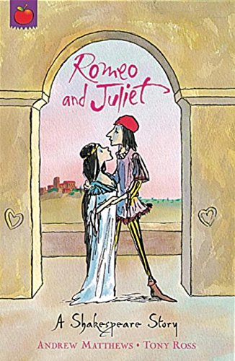
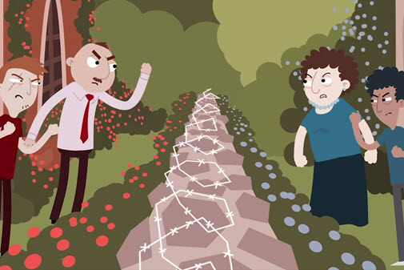

William Shakespeare

William Shakespeare was an English poet, playwright, and actor, widely regarded as the greatest writer in the English language and the world's greatest dramatist. He was born on the 26th April 1564. He wrote 39 plays, 154 sonnets and two narrative poems. His plays have been translated into every major living language and are performed more often than those of any other playwright.
To begin with, let’s look at the prologue to the story.
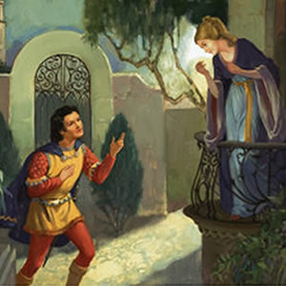
Romeo and Juliet
Two households, both alike in dignity,
In fair Verona, where we lay our scene,
From ancient grudge break to new mutiny,
Where civil blood makes civil hands unclean.
From forth the fatal loins of these two foes
A pair of star-cross'd lovers take their life;
Whose misadventured piteous overthrows
Do with their death bury their parents' strife.
The fearful passage of their death-mark'd love,
And the continuance of their parents' rage,
Which, but their children's end, nought could remove,
Is now the two hours' traffic of our stage;
The which if you with patient ears attend,
What here shall miss, our toil shall strive to mend.
Try these simpler questions first.
- Where is the story set?
- What is wrong with the two households?
- What is the story about?
- Who is the narrator talking to?
- How long is the play?

SCENE I. Verona. A public place.
Enter SAMPSON and GREGORY, of the house of Capulet, armed with swords and bucklers
SAMPSON
Gregory, o' my word, we'll not carry coals.
GREGORY
No, for then we should be colliers.
SAMPSON
I mean, an we be in choler, we'll draw.
GREGORY
Ay, while you live, draw your neck out o' the collar.
SAMPSON
I strike quickly, being moved.
GREGORY
But thou art not quickly moved to strike.
SAMPSON
A dog of the house of Montague moves me.
GREGORY
To move is to stir; and to be valiant is to stand:
therefore, if thou art moved, thou runn'st away.
SAMPSON
A dog of that house shall move me to stand: I will
take the wall of any man or maid of Montague's.
GREGORY
That shows thee a weak slave; for the weakest goes
to the wall.
SAMPSON
True; and therefore women, being the weaker vessels,
are ever thrust to the wall: therefore I will push
Montague's men from the wall, and thrust his maids
to the wall.
GREGORY
The quarrel is between our masters and us their men.
SAMPSON
'Tis all one, I will show myself a tyrant: when I
have fought with the men, I will be cruel with the
maids, and cut off their heads.
GREGORY
The heads of the maids?
SAMPSON
Ay, the heads of the maids, or their maidenheads;
take it in what sense thou wilt.
GREGORY
They must take it in sense that feel it.
SAMPSON
Me they shall feel while I am able to stand: and
'tis known I am a pretty piece of flesh.
GREGORY
'Tis well thou art not fish; if thou hadst, thou
hadst been poor John. Draw thy tool! here comes
two of the house of the Montagues.
SAMPSON
My naked weapon is out: quarrel, I will back thee.
GREGORY
How! turn thy back and run?
SAMPSON
Fear me not.
GREGORY
No, marry; I fear thee!
SAMPSON
Let us take the law of our sides; let them begin.
GREGORY
I will frown as I pass by, and let them take it as
they list.
SAMPSON
Nay, as they dare. I will bite my thumb at them;
which is a disgrace to them, if they bear it.
Enter ABRAHAM and BALTHASAR
ABRAHAM
Do you bite your thumb at us, sir?
SAMPSON
I do bite my thumb, sir.
ABRAHAM
Do you bite your thumb at us, sir?
SAMPSON
[Aside to GREGORY] Is the law of our side, if I say
ay?
GREGORY
No.
SAMPSON
No, sir, I do not bite my thumb at you, sir, but I
bite my thumb, sir.
GREGORY
Do you quarrel, sir?
ABRAHAM
Quarrel sir! no, sir.
SAMPSON
If you do, sir, I am for you: I serve as good a man as you.
ABRAHAM
No better.
SAMPSON
Well, sir.
GREGORY
Say 'better:' here comes one of my master's kinsmen.
SAMPSON
Yes, better, sir.
ABRAHAM
You lie.
SAMPSON
Draw, if you be men. Gregory, remember thy swashing blow.
They fight
Enter BENVOLIO
BENVOLIO
Part, fools!
Put up your swords; you know not what you do.
Beats down their swords
Enter TYBALT
TYBALT
What, art thou drawn among these heartless hinds?
Turn thee, Benvolio, look upon thy death.
BENVOLIO
I do but keep the peace: put up thy sword,
Or manage it to part these men with me.
TYBALT
What, drawn, and talk of peace! I hate the word,
As I hate hell, all Montagues, and thee:
Have at thee, coward!
They fight
Enter, several of both houses, who join the fray; then enter Citizens, with clubs
First Citizen
Clubs, bills, and partisans! strike! beat them down!
Down with the Capulets! down with the Montagues!
Enter CAPULET in his gown, and LADY CAPULET
CAPULET
What noise is this? Give me my long sword, ho!
LADY CAPULET
A crutch, a crutch! why call you for a sword?
CAPULET
My sword, I say! Old Montague is come,
And flourishes his blade in spite of me.
Enter MONTAGUE and LADY MONTAGUE
MONTAGUE
Thou villain Capulet,--Hold me not, let me go.
LADY MONTAGUE
Thou shalt not stir a foot to seek a foe.
Enter PRINCE, with Attendants
PRINCE
Rebellious subjects, enemies to peace,
Profaners of this neighbour-stained steel,--
Will they not hear? What, ho! you men, you beasts,
That quench the fire of your pernicious rage
With purple fountains issuing from your veins,
On pain of torture, from those bloody hands
Throw your mistemper'd weapons to the ground,
And hear the sentence of your moved prince.
Three civil brawls, bred of an airy word,
By thee, old Capulet, and Montague,
Have thrice disturb'd the quiet of our streets,
And made Verona's ancient citizens
Cast by their grave beseeming ornaments,
To wield old partisans, in hands as old,
Canker'd with peace, to part your canker'd hate:
If ever you disturb our streets again,
Your lives shall pay the forfeit of the peace.
For this time, all the rest depart away:
You Capulet; shall go along with me:
And, Montague, come you this afternoon,
To know our further pleasure in this case,
To old Free-town, our common judgment-place.
Once more, on pain of death, all men depart.
Exeunt all but MONTAGUE, LADY MONTAGUE, and BENVOLIO
Questions
1. What is a tool?
2. Who are the two households?
3. What does Lady Montague mean by ‘will not stir a foot to seek a foe’?
4. What do you think the prince’s name is and is he a Capulet or Montague?

Grammar – Punctuation
While simple, punctuation is incredibly important to keep practicing in order to make sure it is perfect! Attempt the tasks underneath, they will come with explanations.
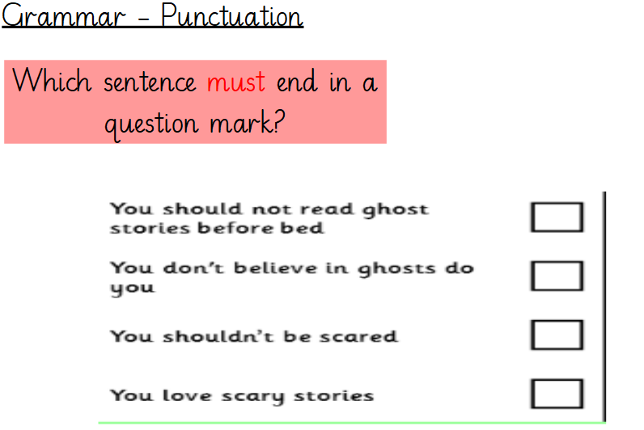
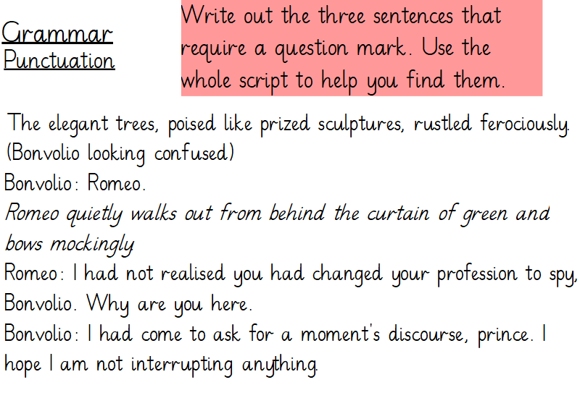
Grammar Task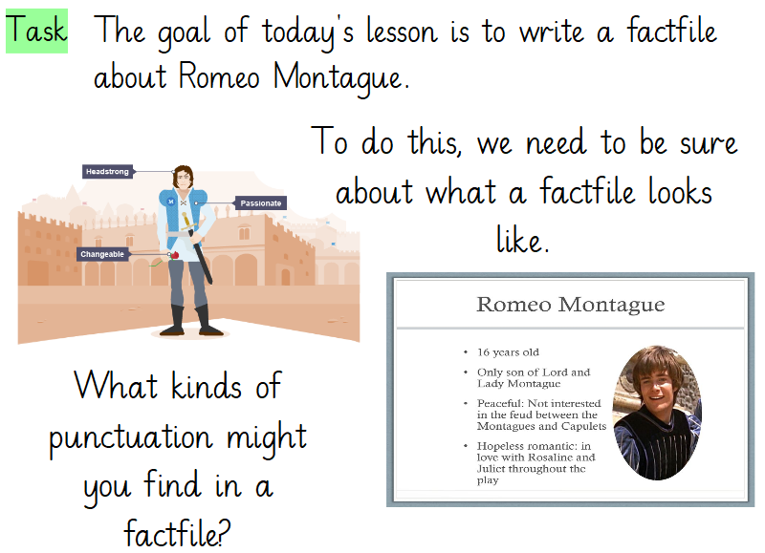
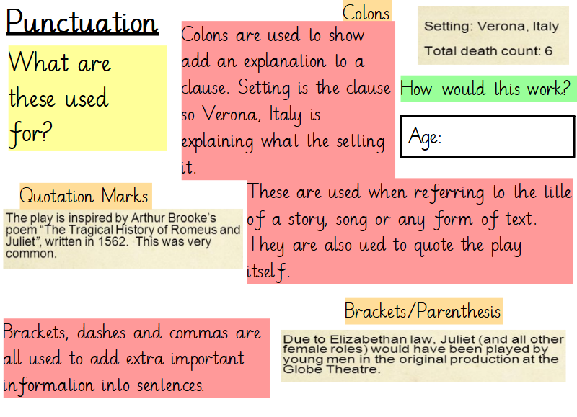
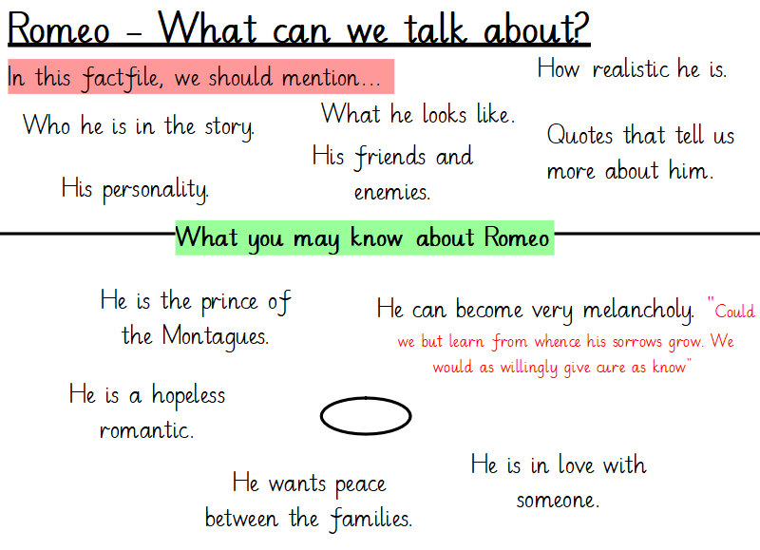
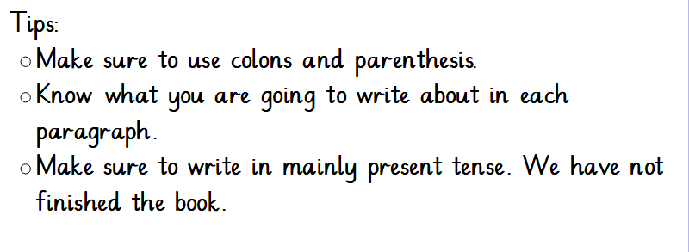
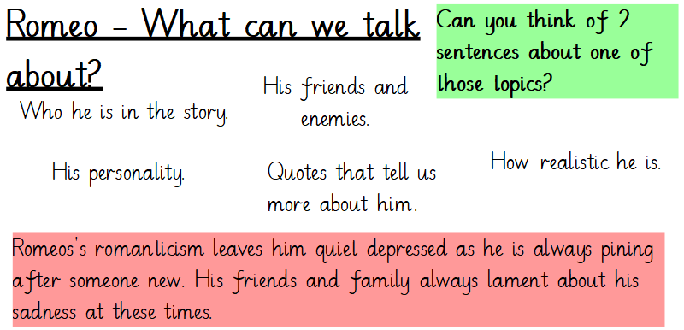

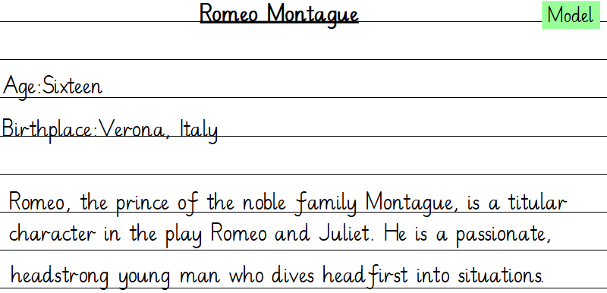

Maths – Revision (Mean, mode, median and range and Volume of cubes and cuboids)
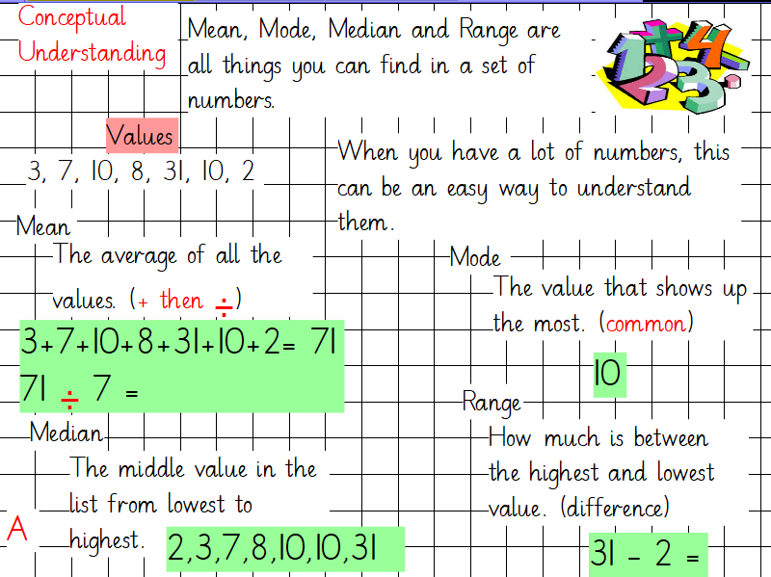
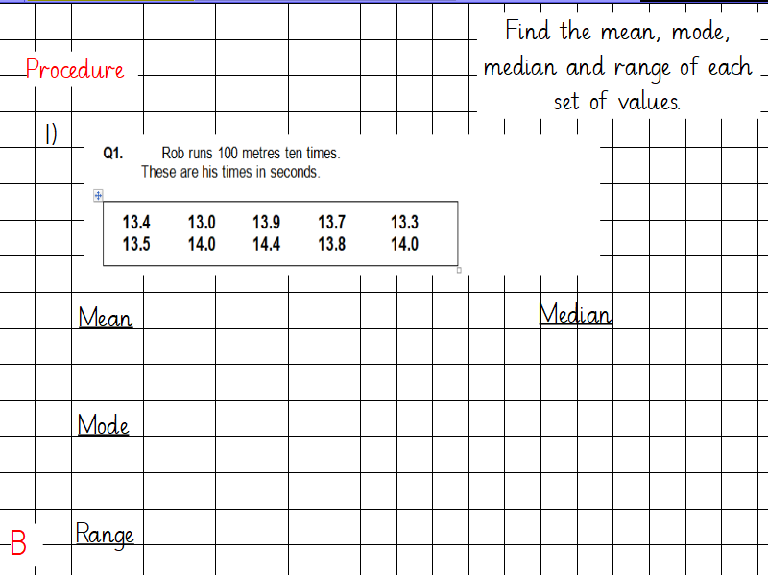
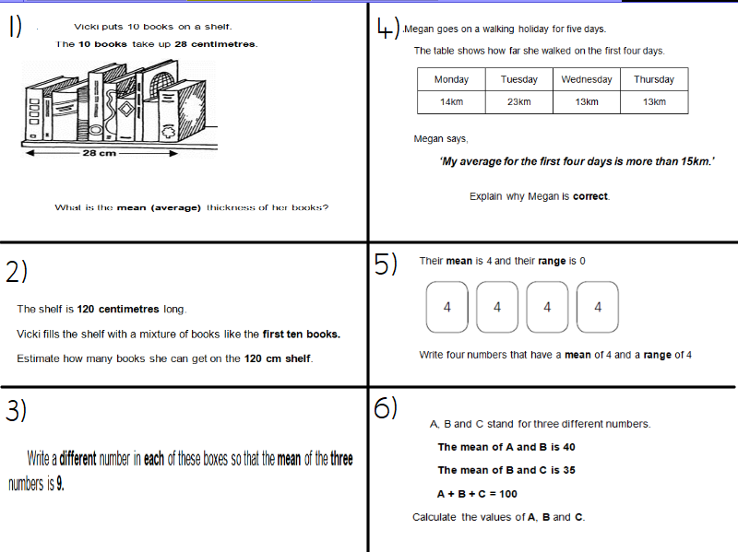

Volume
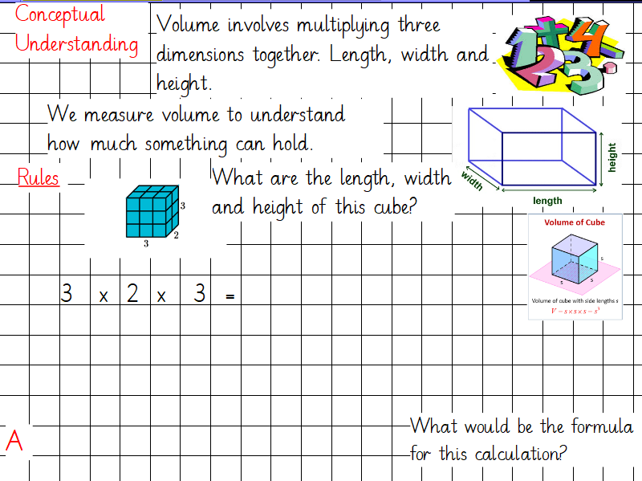
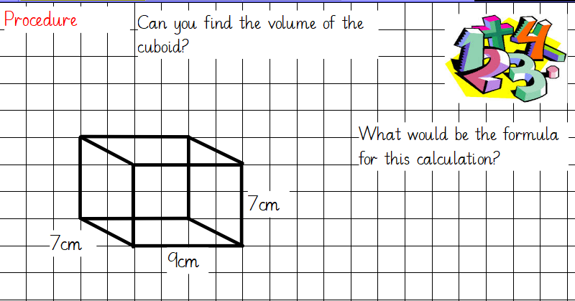
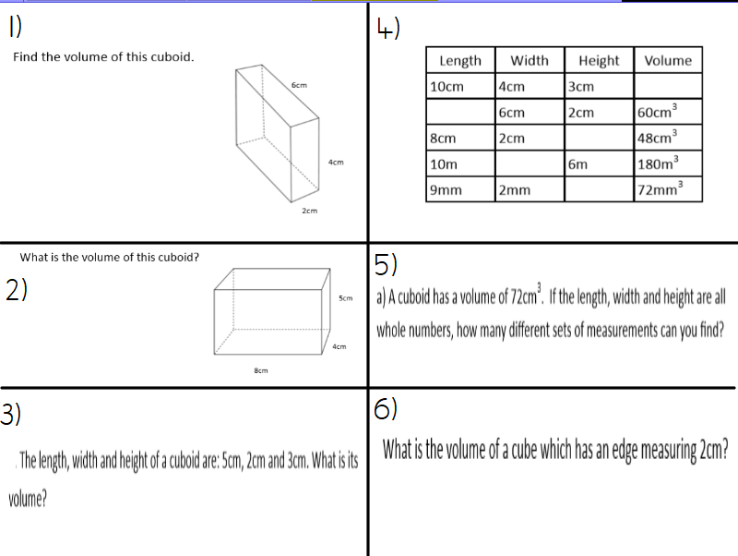
Science – Biology
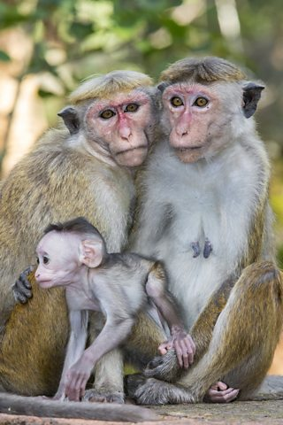
At secondary school, you will be taught Science based on its three key topics. Biology, Chemistry and Physics. To get you prepared for Science in Year 7, we will go over some new learning based on things you already know!
Cells and Life Systems
Living organisms have certain life processes in common.
There are seven things that they need to do to count as
being alive.
The phrase MRS GREN is one way to remember them:
- Movement - all living things move, even plants
- Respiration - getting energy from food
- Sensitivity - detecting changes in the surroundings
- Growth - all living things grow
- Reproduction - making more living things of the same type
- Excretion - getting rid of waste
- Nutrition - taking in and using food
It can be easy to tell if something is living or not. A teddy bear might look like a bear, but it cannot do any of the seven things it needs to be able to do to count as being alive.
A car can move, it gets energy from petrol (like nutrition and respiration), it might have a car alarm (sensitivity), and it gets rid of waste gases through its exhaust pipe (excretion). But it cannot grow or make baby cars. So a car is not alive.
Cells
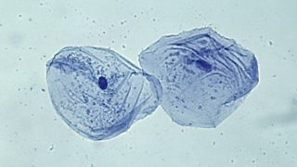
Cells are the basic building blocks of all animals and plants. They are so small, you need to use a light microscope to see them.
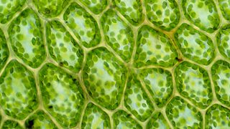

Animal cells and plant cells
Animal cells usually have an irregular shape, and plant cells usually have a regular shape. Cells are made up of different parts.
It is easier to describe these parts by using diagrams:
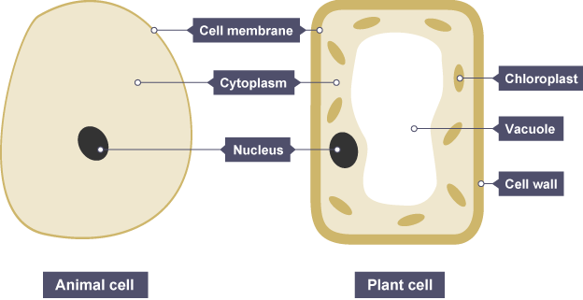
Animal cells and plant cells also contain tiny objects called mitochondria in their cytoplasm.
Animal cells and plant cells both contain:
- cell membrane
- cytoplasm
- nucleus
- mitochondria
Plant cells also contain these parts, which are not found in animal cells:
- cell wall
- vacuole
- chloroplasts
The table summarises the functions of these parts:
Part | Function | Found in
Cell membrane | Controls the movement of substances into and out of the cell | Plant and animal cells
Cytoplasm | Jelly-like substance, where chemical reactions happen | Plant and animal cells
Nucleus | Carries genetic information and controls what happens inside the cell | Plant and animal cells
Mitochondria | Where most respiration reactions happen | Plant and animal cells
Vacuole | Contains a liquid called cell sap, which keeps the cell firm | Plant cells only
Cell wall | Made of a tough substance called cellulose, which supports the cell | Plant cells only
Science Test
Try these questions.
  - Getting rid of waste is one of the life processes. What name is given to this process?
  - What type of cell is this likely to be?
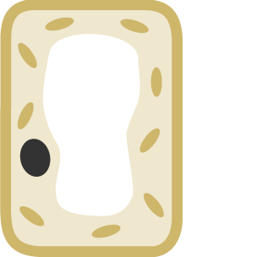

  - What is shown by the labelling line X?
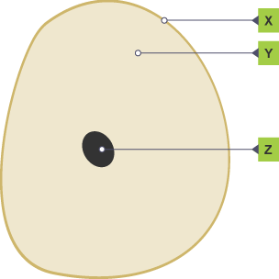

  - What is shown by the labelling line Y?

