The Year Six Newsletter

We hope you and your families are doing well.
Thank you for all the great work you have continued to complete over the last week. I know myself; Ms Foster and Mr Bennett have enjoyed reading it and commenting on it. We would really like to see what you have been up to at home so please feel free to send in any photos of things you have been doing or creating.
Please continue to check Purple Mash for weekly tasks and use Serial Mash to continue your reading. If you’ve been having trouble accessing Purple Mash visit: https://www.purplemash.com/sch/shaftesbury-e7 and enter your username and password (this is the same details you use during computing lessons). Remember, make sure the school selection is Shaftesbury Primary school. Do not forget to also look at the school’s website for updates on home learning. You can visit: https://www.shaftesburyprimaryschool.co.uk/page/?title=School+Closures&pid=101 alternatively when on the Shaftesbury website visit- Parents- School Closure.
Teacher’s corner
I would just like to show you a few things that have been keeping me (Mr Everard) occupied over the last few weeks.
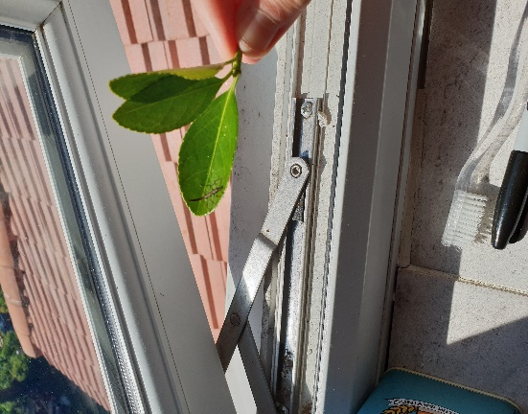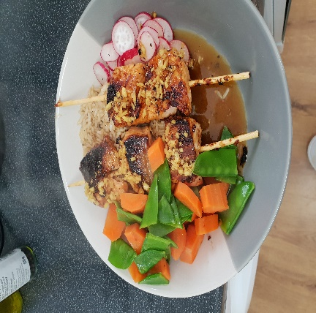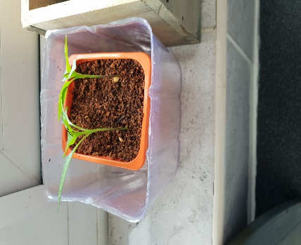
I have become the proud father to three Indian stick insects. Can you see one of them? Also, I have been brushing up on my cooking (Salmon skewers… a bit burnt!) and nurturing some small chilli plants. SPICY!!!
English
Reading comprehension
This week, we have been truly fortunate to have the wonderful storyteller Vanessa Woolf deliver personal performances for us on Youtube.
If you failed to view the performances, then please follow the links below and watch them before answering the questions:
https://www.youtube.com/watch?v=jsB-8fOLd7Y&t=44s - Lady of Stavoren
https://www.youtube.com/watch?v=SOKEgYTITPA - Freedom Bird
The Lady of Stavoren
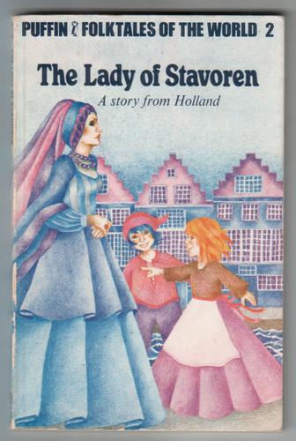
How many endings does the story have?
What is a ‘port’?
Provide two reasons why a gold hat may prove uncomfortable?
What impression do you get of the ‘lady’?
Why was she speechless when she saw the sea captain?
Give three concerns the lady had about the sea captain.
What present do you think she would request?
Was it important that the wheat could grow?
Freedom Bird
What do you think turned the king ‘evil’ before this story began?
The letter was written anonymously. What does this mean?
Vanessa reassures us the ‘stunt rabbit’ will not get hurt. Why?
Explain the moral of the story.
How are we able to show freedom in our everyday lives?
Writing
Title: Do we take freedom for granted?
Create a balanced argument on the topic of ‘freedom’.
Questions to consider while writing – What freedoms do we have at school/home/the community? Is every country the same? What is the importance of having a freedom to choose things for yourself? Is it important to have your own views and opinions?
Sentence openers
The issue of freedom is one that varies across the globe and depends on the views of governments and communities….
It could be argued that without certain freedom, we would not be able to challenge decisions and explore creative processes….
On the other hand, excessive freedom could lead to a break down in society, where rules play an important part in maintaining a peaceful day to day life….
Overall, I believe…….

Grammar – modal verbs
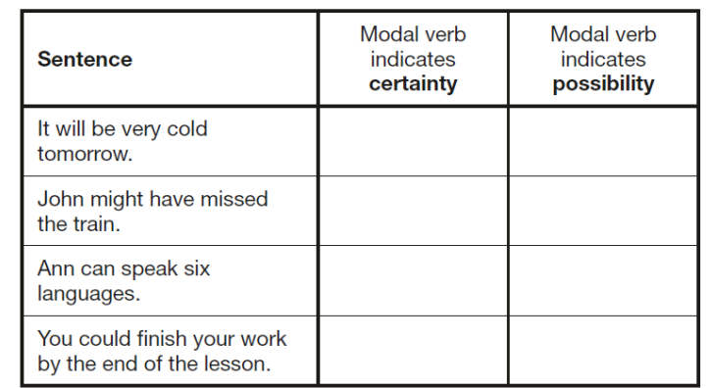
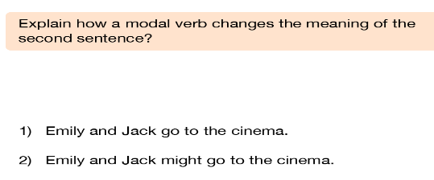

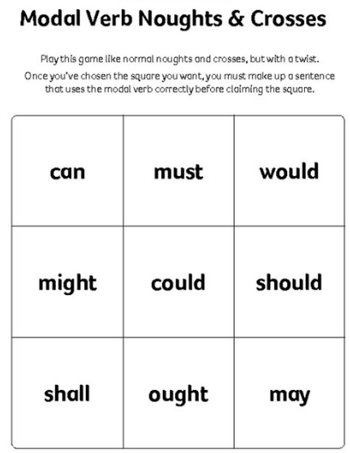
Maths
Multiplication is one of the four operations that helps us build the platform for mathematical knowledge. It constantly assists us in everyday life when we calculate the price of three packets of crisps or the price of six cinema tickets. Mr Everard needs his multiplication skills when he visits Greggs, otherwise he might not have enough money to buy all those doughnuts!
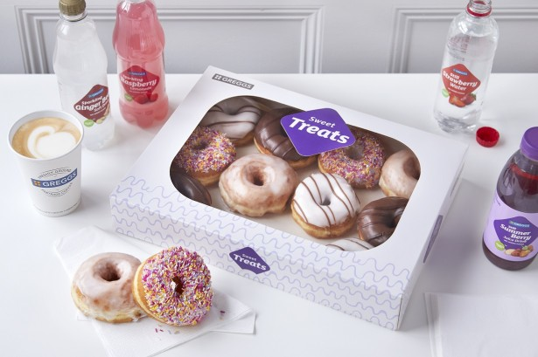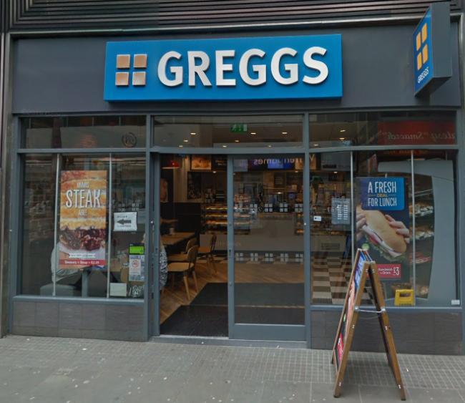
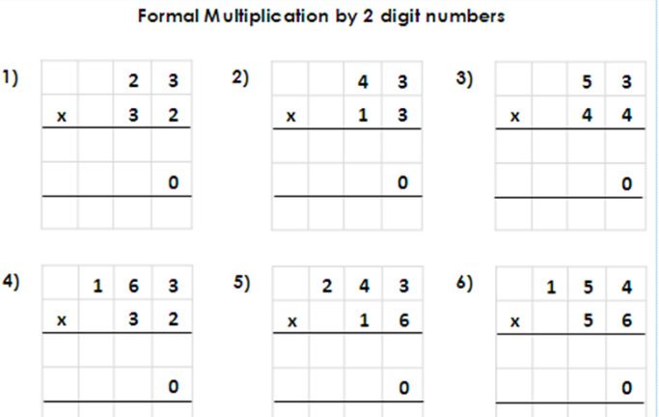

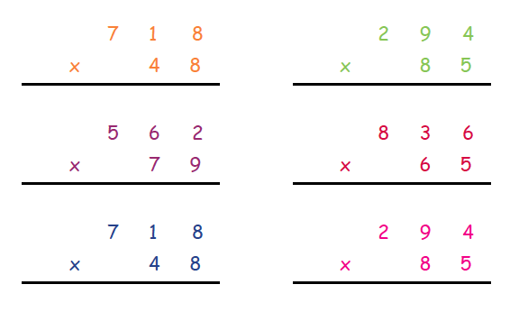
Can you identify the missing digits?
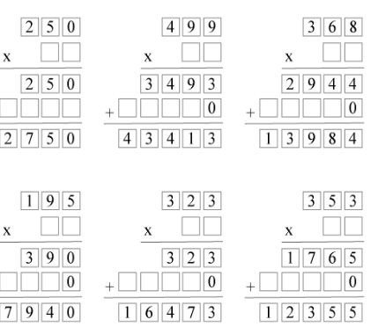

These multiplication problems are taken from previous SATS papers. Can you solve them?
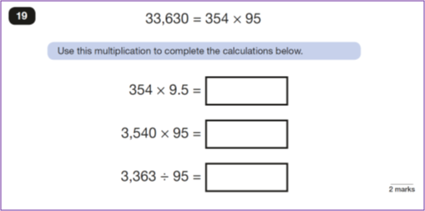
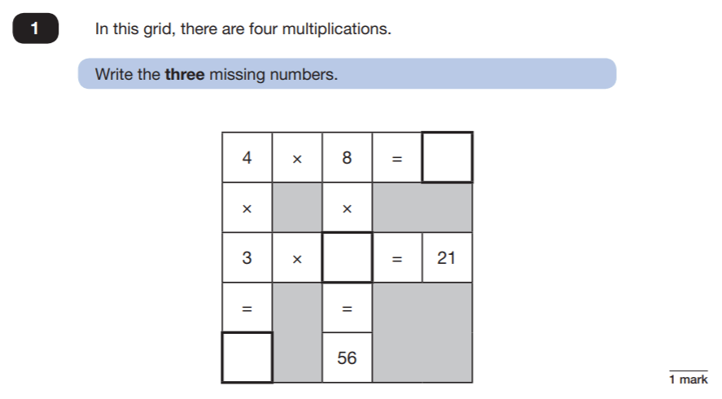

Science
I LOVE SCIENCE!!
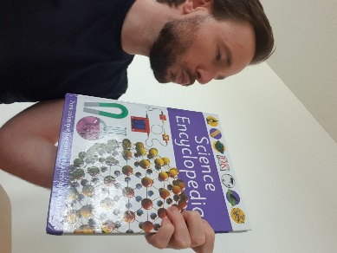
I have placed the links to some ONLINE science lessons that are a FANTASTIC way for year six to keep up their development of the subject. Please see the link below:
https://www.stem.org.uk/remote-lessons/key-stage-2
The lessons above, are based around the digestive system, circulatory system, and adaption. PLEASE take a look. Each lesson comes with a downloadable worksheet that you can use along with watching the videos.

THE CREST AWARDS
As the Science Lead at Shaftesbury, I have been passionate about celebrating the children’s talents in Science. THE CREST AWARDS are a wonderful way of children working towards a certificate and badge accredited by The British Science Association.
There are links to THE CREST AWARDS in the home learning section of the school website under ‘Science’. I have also, added a link below.
https://primarylibrary.crestawards.org/all-superstar-challenges/61747644
These activities can be completed, and a certificate will be awarded once EIGHT activities are completed.
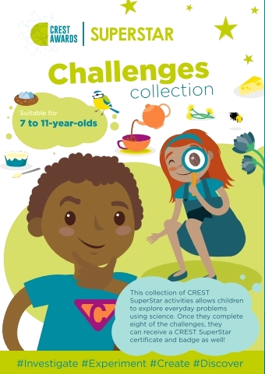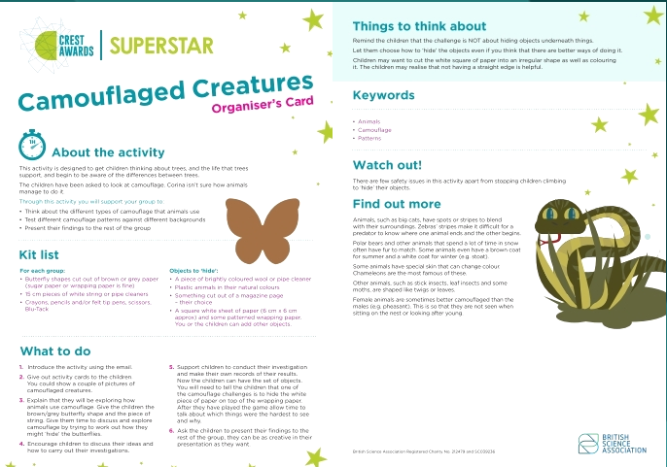

I have provided a CREST AWARDs activity below. Please complete it and start your journey towards success.

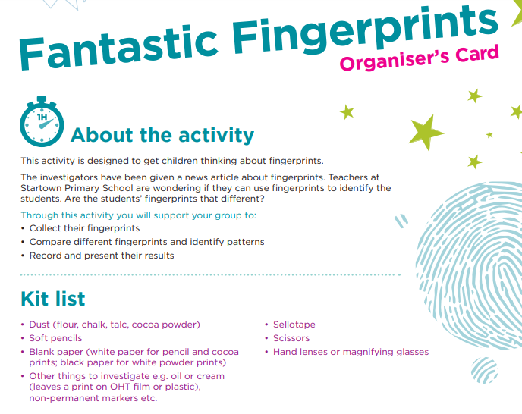
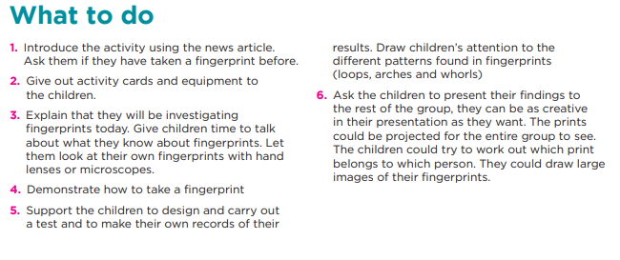

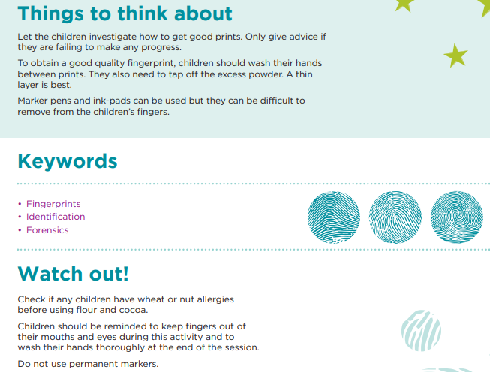
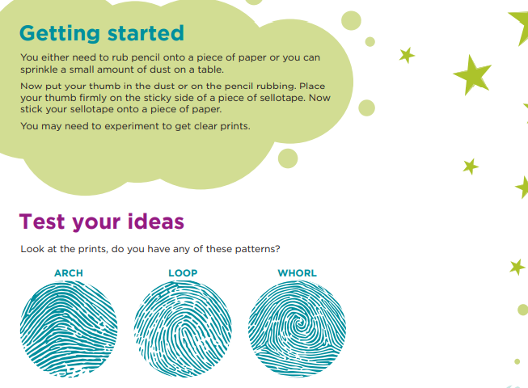

Art – Roy Lichtenstein
In September 2019, we studied the work of Roy Lichtenstein. He was a renowned artist, who rose to fame in the 1960s. His specific style of using the ‘benday dot’ effect won him many admirers during the ‘Pop art’ era.
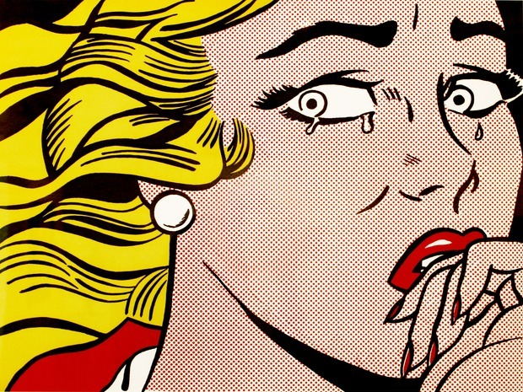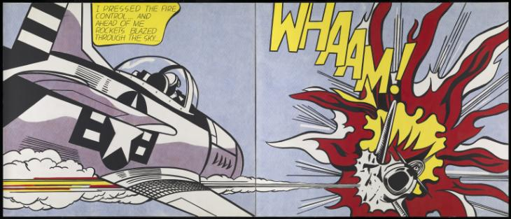

Below is my version of one of his pieces of artwork:

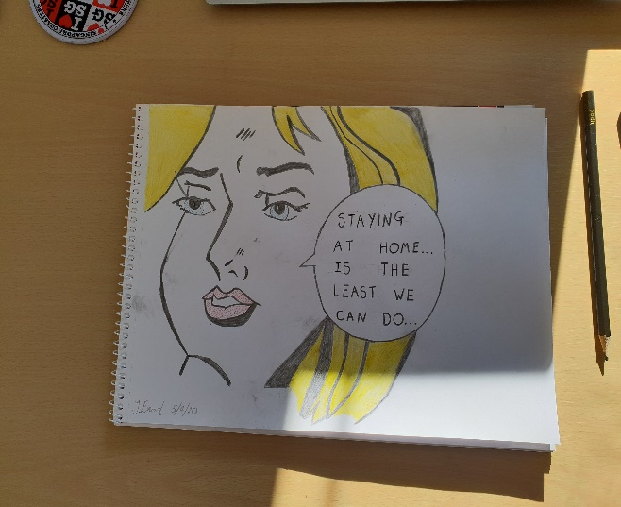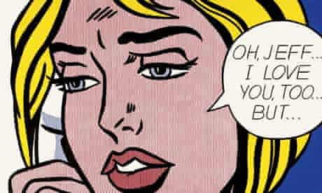
Task
Use the image below to create your own version of Roy Lichtenstein’s artwork. PLEASE send them in for us to share on the school website.
