The Year Six Newsletter

We hope you and your families are doing well.
Thank you for all the great work you have continued to complete over the last few weeks. I know myself; Ms Foster and Mr Bennett are proud of your efforts. We would really like to see what you have been up to at home so please feel free to send in any photos of things you have been doing or creating.
Please continue to check Purple Mash for weekly tasks and use Serial Mash to continue your reading. If you’ve been having trouble accessing Purple Mash visit: https://www.purplemash.com/sch/shaftesbury-e7 and enter your username and password (this is the same details you use during computing lessons). Remember, make sure the school selection is Shaftesbury Primary school. Do not forget to also look at the school’s website for updates on home learning. You can visit: https://www.shaftesburyprimaryschool.co.uk/page/?title=School+Closures&pid=101 alternatively when on the Shaftesbury website visit- Parents- School Closure.
Teacher’s corner
I would just like to show you a few things that have been keeping me (Mr Everard) occupied during my Summer break.
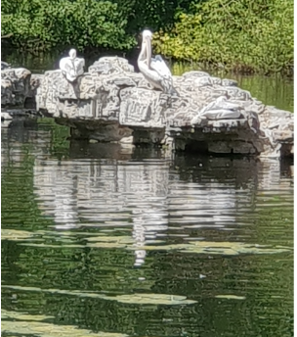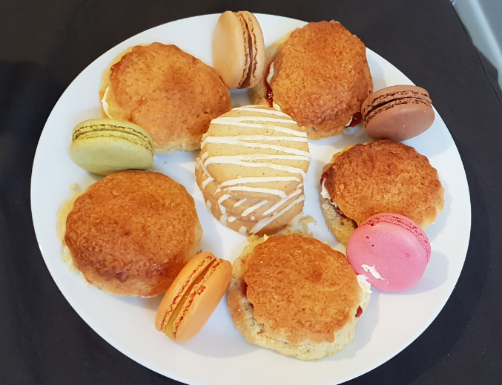
In the last few weeks, I have visited St James Park in London. Do you know where that is? Could you find out? The park is teeming with wildlife and these birds were a joy to behold! Do you know what they are? Please try and find out…
Furthermore, I have been tucking into these macaroons and scones…delicious! What type of biscuits do you like? In my opinion, scones and tea are the perfect match!

English
Reading comprehension
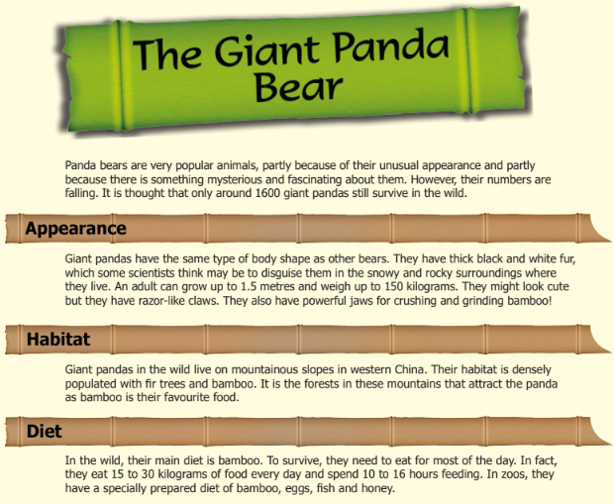
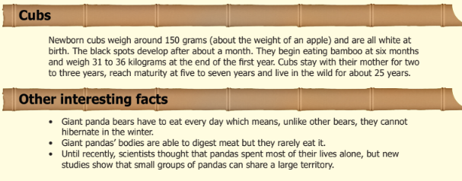
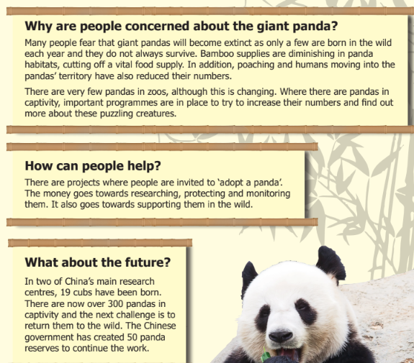
Questions
- According to the text, approximately how many giant pandas currently live in
the wild?

- According to some scientists, how does giant pandas’ fur help them
to survive in the wild?

- Look at this sentence.
Pandas can grow up to 1.5 metres and weigh up to 150 kilograms.
What else in the text tells us that giant pandas could be dangerous animals?

- According to the text, what do pandas spend the majority of their
time doing?

- According to the text, give one way that giant pandas are...

- similar to other bears.

- different from other bears.

- Look at the section headed: Why are people concerned about the
giant panda?
Find and copy one word which shows that there are lots of things we
do not yet know about giant pandas.

- Look at the section headed: What about the future?
Find and copy one word that shows that helping the giant panda is
not easy.

Grammar
A statement sentence asserts or declares a fact, opinion, or idea. Statement sentences never ask a question, give a command, or make a request. A simple example would be: The door is green.
Can you answer these questions?
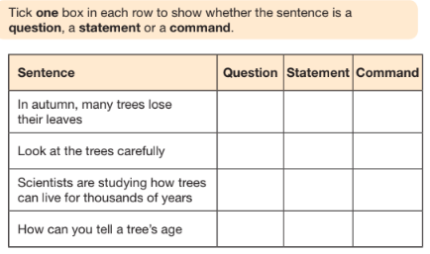

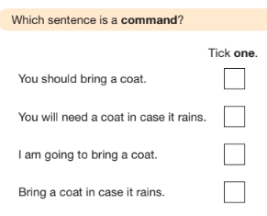
Can you explain why that sentence is a command? What about the others?

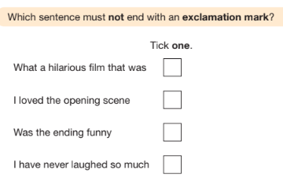
Why does this sentence not need an exclamation?
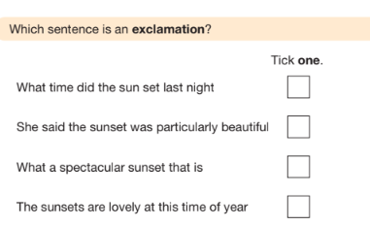
Why does this sentence need an exclamation?

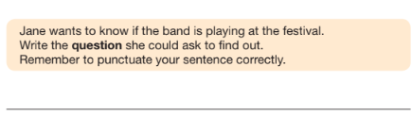

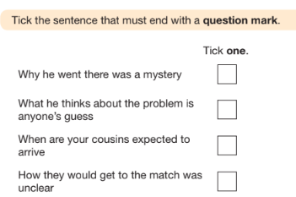
Can you explain why the other sentences do not need a question mark?
Maths
Interpreting data is the process of reviewing data through some processes which will help give some meaning to the data and arrive at a certain conclusion. It involves taking the result of data analysis, making inferences, and comparing numbers and percentages. Data can be presented in charts, graphs, or tables.
Please answer these questions:

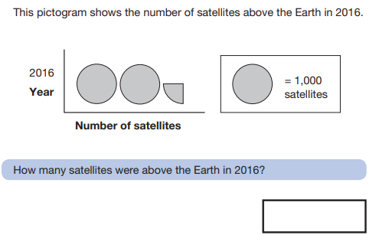

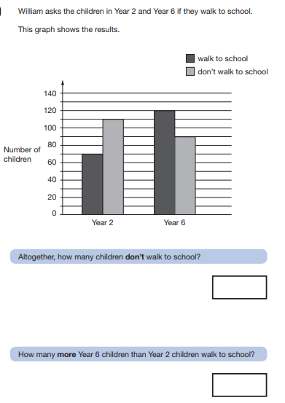

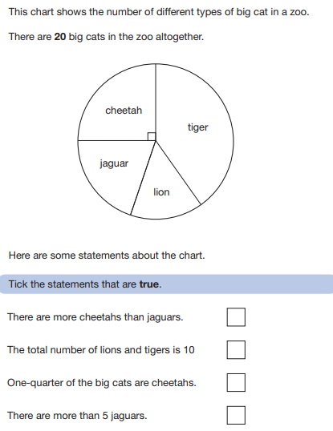

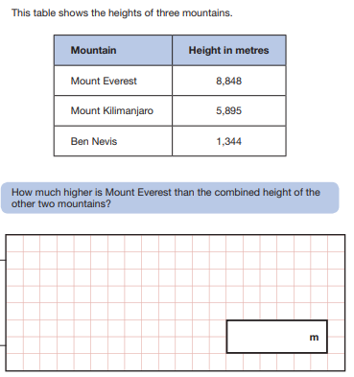

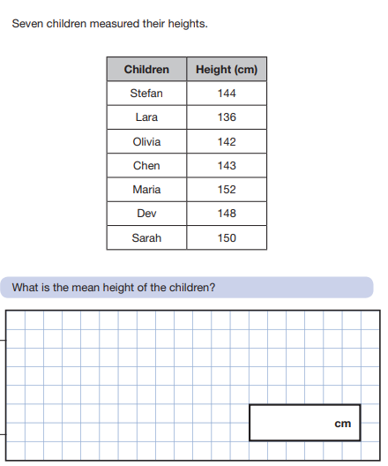
Science
I LOVE SCIENCE!!
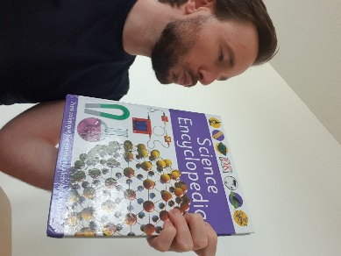
I have placed the links to some ONLINE science lessons that are a FANTASTIC way for you to keep up your development of the subject. Please see the link below:
https://www.stem.org.uk/remote-lessons/key-stage-2
The lessons above, are based around the digestive system, circulatory system, adaption electricity and forces. PLEASE take a look. Each lesson comes with a downloadable worksheet that you can use along with watching the videos.

THE CREST AWARDS
As the Science Lead at Shaftesbury, I have been passionate about celebrating the children’s talents in Science. THE CREST AWARDS are a wonderful way of children working towards a certificate and badge accredited by The British Science Association.
There are links to THE CREST AWARDS in the home learning section of the school website under ‘Science’. I have also, added a link below.
https://primarylibrary.crestawards.org/all-superstar-challenges/61747644
These activities can be completed, and a certificate will be awarded once EIGHT activities are completed.
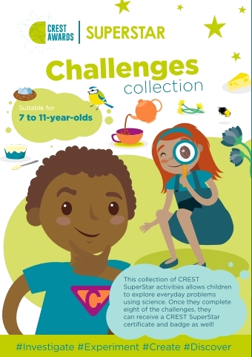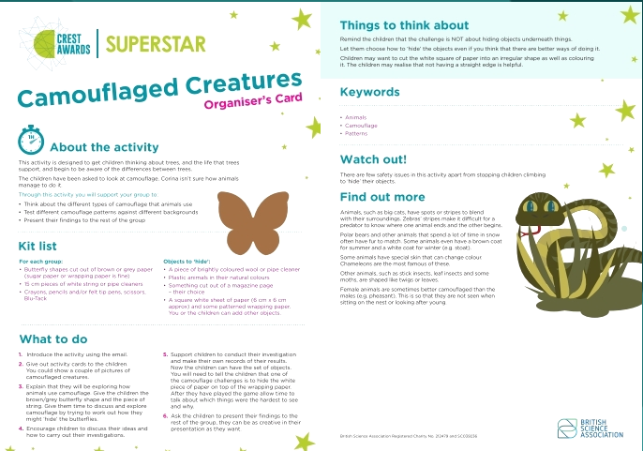

I have provided a CREST AWARDs activity below. Please complete it and start (or continue) your journey towards success.
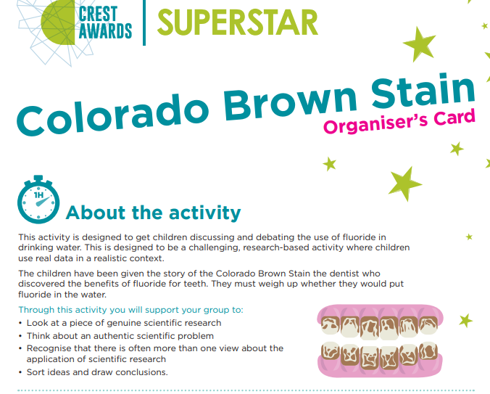
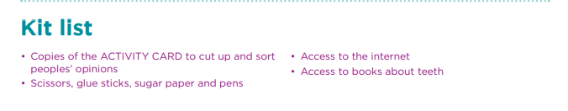

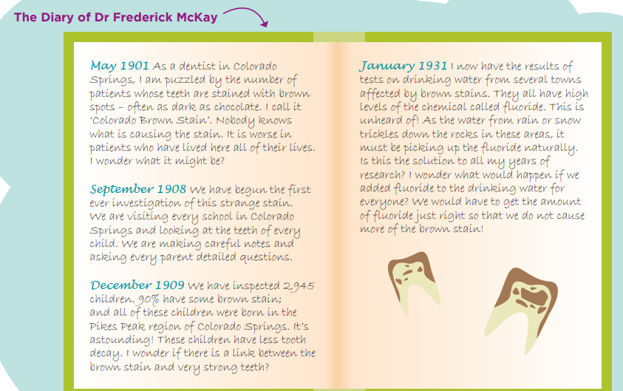
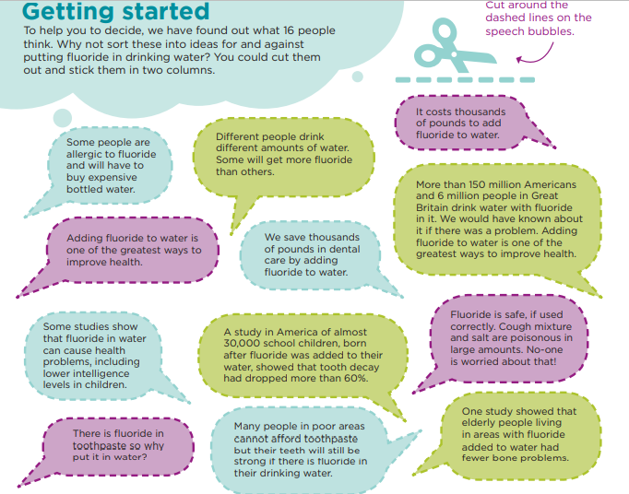

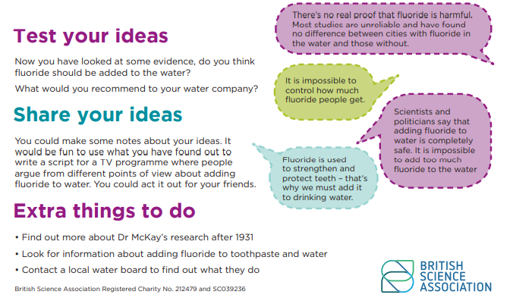

Art – using tone in our drawings.
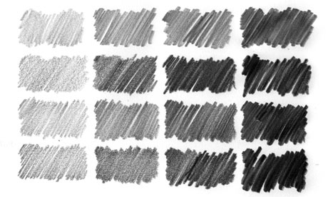
Tone describes the lightness or darkness of an object. By using tone effectively with our pencil, we can create three-dimensional figures and objects.
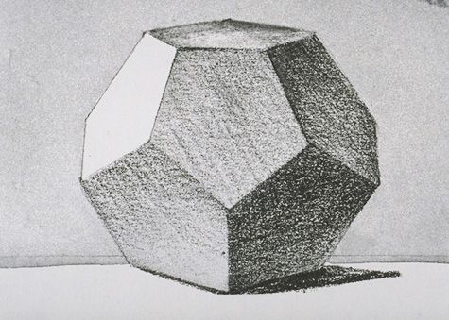
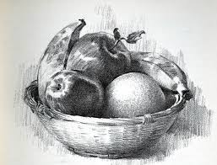

Can you recreate one of these images using tone effectively?

