The Year Six Newsletter – Week 5

Hello Year 6,
We hope you have been enjoying your summer holidays and have been able to reconnect with family and friends.
As always, we continue to hope you and your families are doing well. We also hope that you are looking forward to going to your new secondary schools, there is not long left now. We continue to thank you for all the great work you have continued to complete over the last few months and hope the work provided over the summer holidays has kept you engaged in your learning. It has been an absolute pleasure teaching you all this year and we wish you the best of luck in secondary school and beyond.
Remember, you can still access transition packs from the school’s website. Please make sure you have completed the packs before you start school in September.
Visit: https://www.shaftesburyprimaryschool.co.uk/page/?title=School+Closures&pid=101 alternatively when on the Shaftesbury website visit- Parents- School Closure.
Best wishes and good luck,
Ms Foster, Mr Bennett and Mr Everard
English
Reading Comprehension
Please read the following transcript below. Once you have read the narrative watch the video to get a visual representation.
https://www.literacyshed.com/francis.html
Francis
When I was a kid in the suburbs of Chicago, adventure meant Quetico Provincial Park, up on the border of Minnesota and Canada. The name implies that the place was small, but Quetico is a million acre nature preserve, so big you could go days and days without seeing another soul.
We would go on camping trips up there, weeks of canoeing and portaging, seeing bears and moose and deer, sleeping under star-soaked skies. The park was isolated and so pristine that you could actually drink the water straight from the lakes. But I won't be going back to Quetico anytime soon. Not after what happened to a girl name Francis Brandywine.
Francis was 17 at the time, black haired and with a reckless nature, determined always to leave the well-trod path, to break new ground and be alone. A few years ago, Francis was up in Quetico with her family. They were in a remote part of the park, camped on the shore of one of the deeper lakes, a lonely body of water carved millions of years ago by a passing glacier. The deep part of this particular lake was rumoured to be about 300 feet.
One night, after her family went to bed, Francis took the row boat out, planning to find a quiet spot in the middle of the lake, lay on the bench of the boat, look up at the sky, and maybe write in her journal.
So she left the shore, rowed for about 20 minutes, and when she felt satisfied that she was over the lake's deepest spot, she lay down on the bench and looked up at the night sky. The stars were very bright, and the aurora borealis was shimmering like a neon lasso. She was feeling very peaceful.
Then she heard something strange. It was like a knock. Clop, clop. She sat up, guessing that the boat had drifted to shore and run aground. But she looked around the boat, and she was still a half mile from shore. She leaned over the side to see if she'd hit anything, but she saw nothing-- no log, no rocks. She lay back down.
She told herself it could be any number of things, a fish, a turtle, a stick that had drifted under the boat. She relaxed again and soon fell into a contented reverie. She had just closed her eyes when she heard another knock. This time it was louder, a crisp plop, plop, plop, like the sound of someone knocking hard on a wooden door, except this knocking was coming from the bottom of the boat.
Now she was scared. She leaned over the side again. It had to be an animal. But what kind of animal would knock like that, three quick, loud knocks in rapid succession? Her mouth went dry. She held onto each side of the boat, and now she could only wait to see if it happened again. The silence stretched out. A few minutes passed, and just as she began to think she'd imagined it all, the knocks came again, but this time louder. Bam, bam, bam.
She had to leave. She lunged for the oars. She got them in place and began rowing. The water was very calm, so she should've made quick progress. But after rowing feverishly, she looked around, and she realized that she wasn't moving at all. Something was keeping her exactly where she was.
Again she tried rowing, she rowed and rowed on the verge of tears, but she went nowhere. She stopped. She was exhausted. Her heavy breathing filled the air. She cried. She sobbed. But soon she calmed herself again, and the boat was silent again, for 10 minutes, then 20.
Again, she tricked herself into thinking she'd imagined it all. But just like before, just when she was beginning to get a grip on herself, the knocking came again, this time as loud as a bass drum. Boom, boom, boom. The floorboards of the boat shook with each knock. Now she was so shaken she started making questionable decisions. The first was to lower one of the oars into the black water, trying to feel if there was some land mass, even some creature she could touch. As soon as the oar broke the water's surface, though, she felt a strong, silent tug at the other end, and the oar was pulled under.
She screamed, she jumped back, and now she had no options. All she could do was sit, and hope, and wait-- wait for the morning to come, wait for whatever was going to happen to happen. The knocking went on through the night. She passed the time writing in her notebook, and it's only because of this notebook that we know what happened that night. Frances can't tell us. She was never seen again.
The boat was found on shore the next day, empty but for the journal. On those pages were her frantic jottings, all written in her distinctive handwriting, all but the last page. When the journal was found, that page was still wet, and on it were four words, looking as if they'd been written quickly, with a muddy finger. They said, "I did knock first."
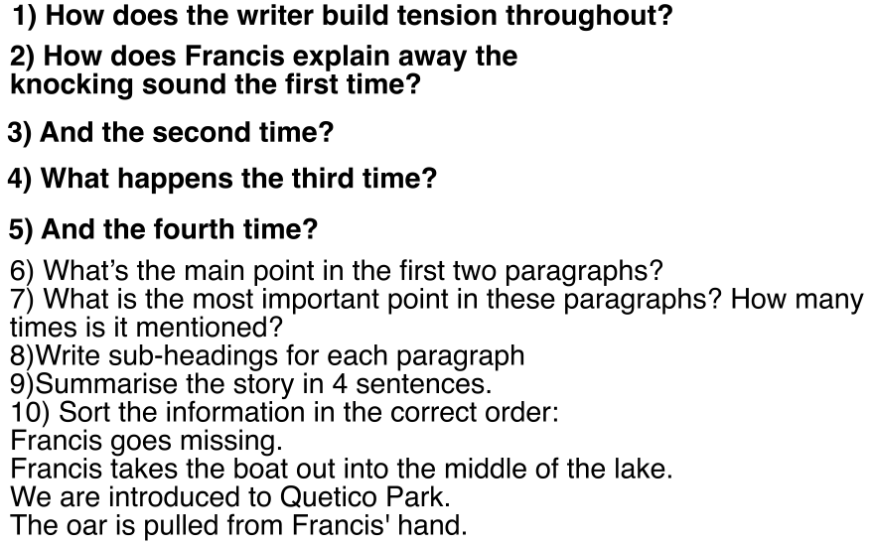
Questions
1) What do you think is knocking on the boat? Explain your choice, using evidence from the text.
2) Why did Francis write in her journal? Why is this important?
3) Do you think Francis has survived ? Give your reasons based on the text.
4) Why have short sentences been used throughout the story?
5) Why did the author choose this setting? Will that influence how the story develops?
6) Is Francis like someone you know? Do you think they will react in the same way? If not, how may someone else you know react in this situation?
7) Do you think this will happen again? Why?
8) Who do you think wrote on the last page of Francis' journal?

Challenge questions.

Grammar – Punctuation
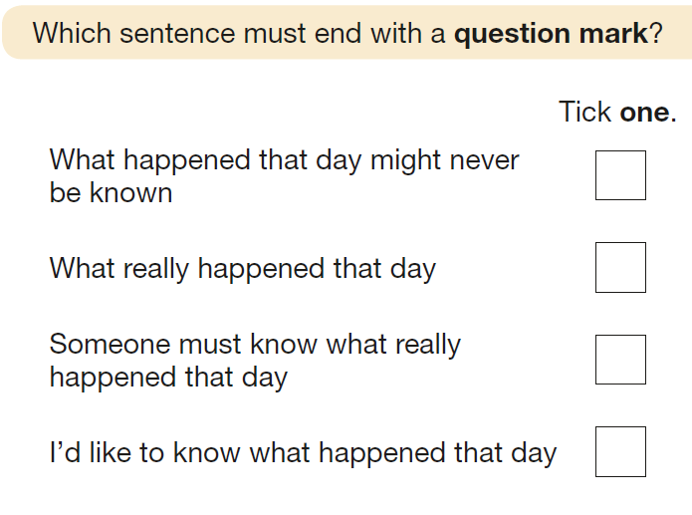

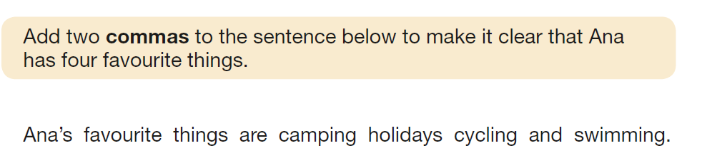

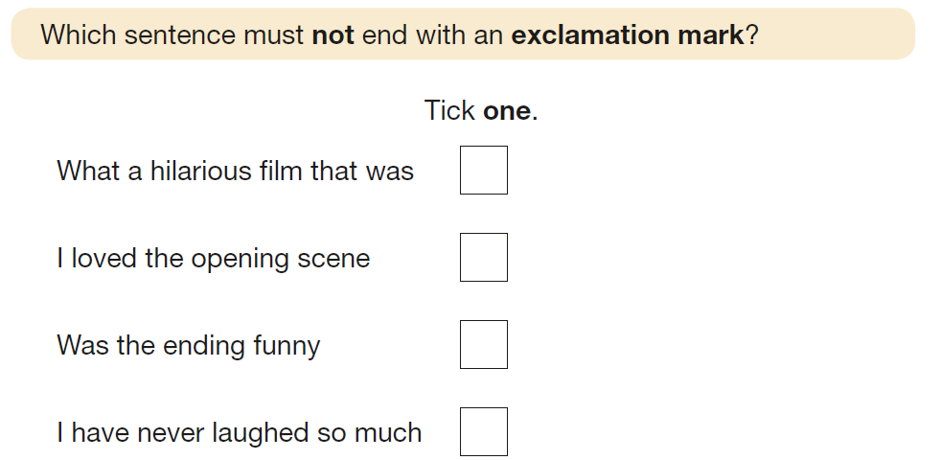

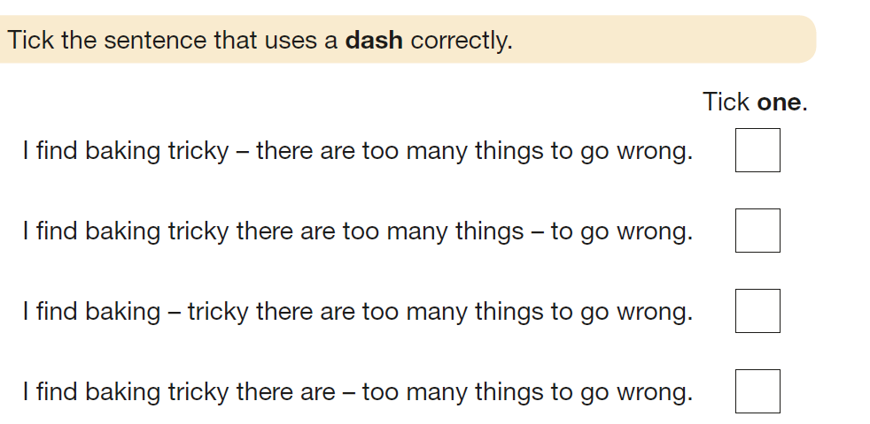
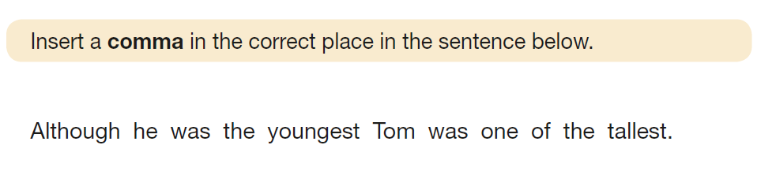
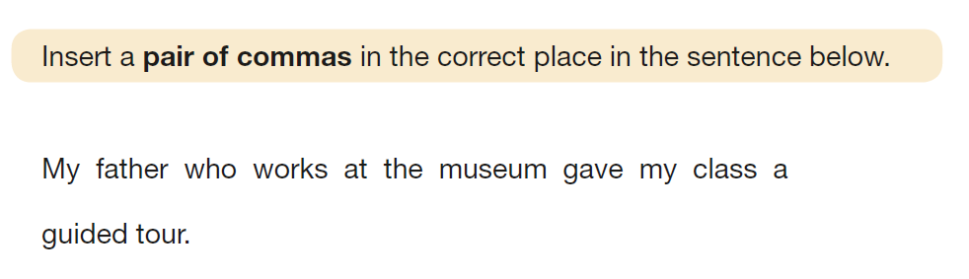

Writing time

We would like you to write a sequel. A sequel is a follow on story that uses characters and familiar settings from the original story. Can you tell us what happened to Francis? Can you reveal the secrets that were left behind in her diary?
Write at least 6 paragraphs (if you can try to write more)
Have you written in the past tense?
Have you used descriptive language? Fronted adverbials? Relative clauses? Rhethorical questions?

Challenge: Can you write your own playscript for your story or for the original narrative of ‘Francis’ above?

Sentence challenge!
Can you use semi-colons to join two independent clauses together?
Can you create interesting noun phrases?
Can you use subordinate conjunctions to start sentences?
Can you create dialogue?
Can you use adverbs in a range of different ways throughout your writing?
Can you edit your writing and make it better?

Maths – Calculation (BODMAS)
Recap your calculations skills ahead of starting Year 7. You will use calculation skills throughout your life. Practice them often.
Warm up

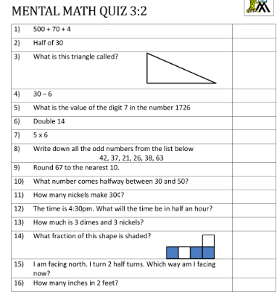

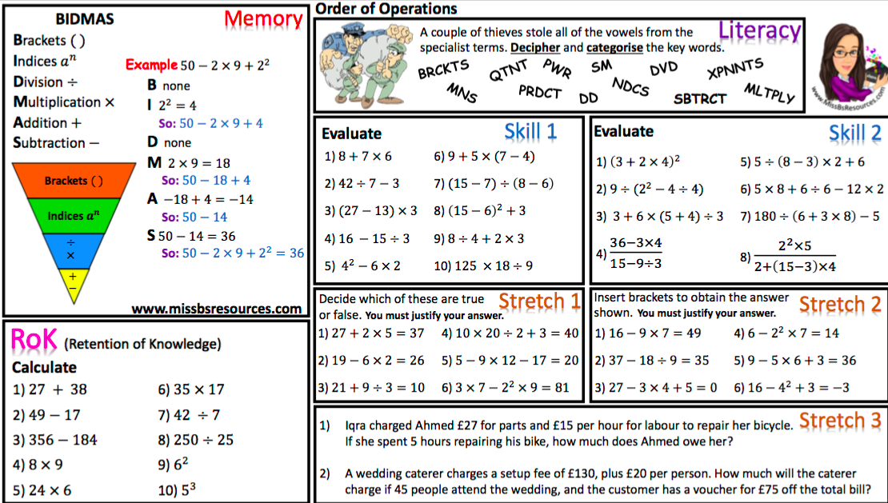
Science
Try to make your own lava lamp, see how light refracts and experiment with milk and food colouring. All activities can be done with items you probably already have in your homes.

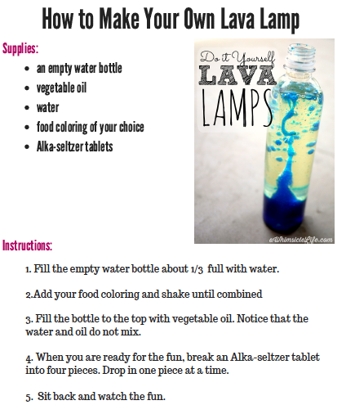

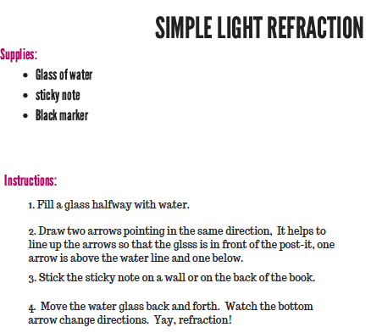

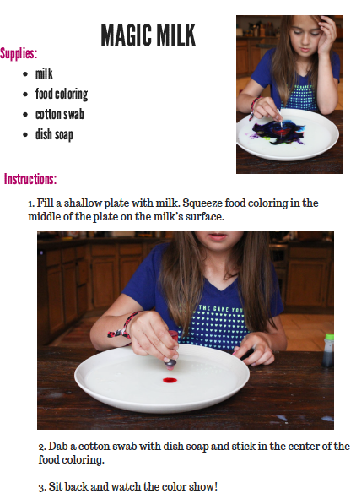
P.E
Create a game to play at home with family are friends that keeps you all active. If you haven’t got balls, improvise with other things you have at home. Use sports day as inspiration.

Art/ DT – Recycle project! Two week project.
Use an empty shoe box/ box to create a game, safe box, money box, dolls home etc.
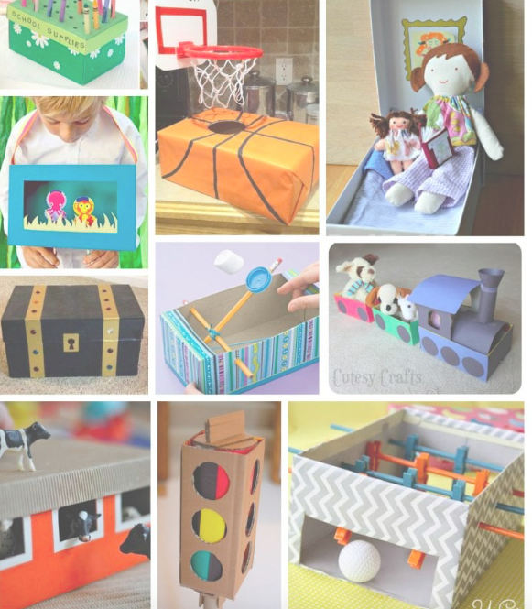
Look at the following designs for inspiration. Can you find any other items around your home that you can recycle and use within your design. Be as creative as you can be! Good luck and it would be great to see some

