The Year Six Newsletter

We hope you and your families are doing well.
Thank you for all the great work you have continued to complete over the last few weeks. I know myself; Ms Foster and Mr Bennett are proud of your efforts. We would really like to see what you have been up to at home so please feel free to send in any photos of things you have been doing or creating.
Please continue to check Purple Mash for weekly tasks and use Serial Mash to continue your reading. If you’ve been having trouble accessing Purple Mash visit: https://www.purplemash.com/sch/shaftesbury-e7 and enter your username and password (this is the same details you use during computing lessons). Remember, make sure the school selection is Shaftesbury Primary school. Do not forget to also look at the school’s website for updates on home learning. You can visit: https://www.shaftesburyprimaryschool.co.uk/page/?title=School+Closures&pid=101 alternatively when on the Shaftesbury website visit- Parents- School Closure.
Teacher’s corner
I would just like to show you a few things that have been keeping me (Mr Everard) occupied during my Summer break.
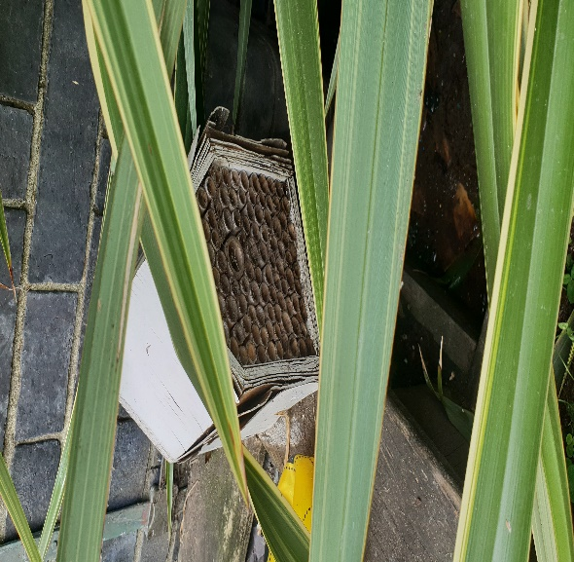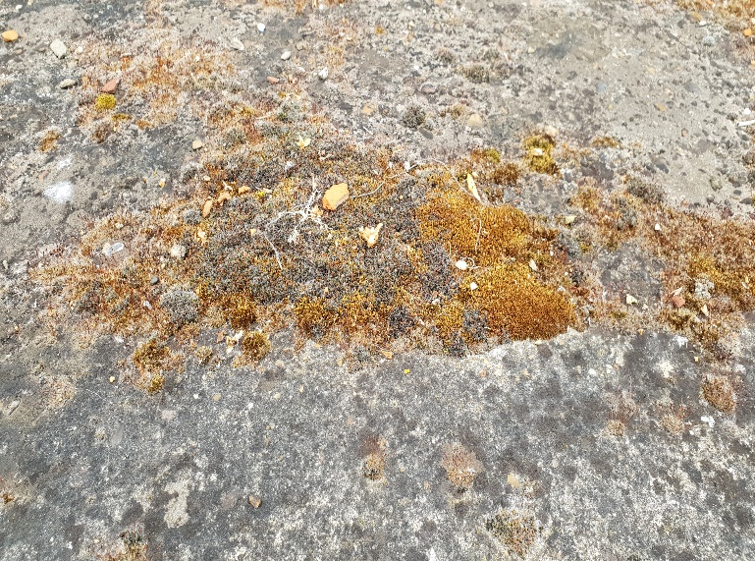

In the last few weeks, I have been spending time in the garden. Do you know what it means to have ‘green fingers’? In the first picture, it shows a ‘bee hotel’. Do you know the benefit of building them? Why are bees important?
In addition, the second picture shows some moss growing on the pavement. Can you find out something about moss and ferns? Does moss require light? Produce seeds? Please find out!

English
Reading comprehension
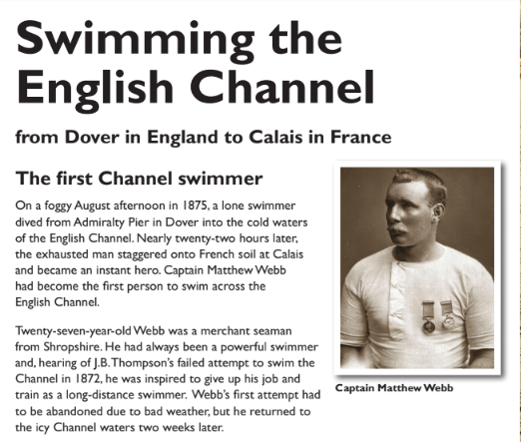
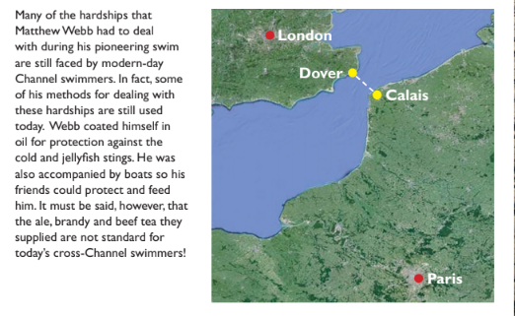

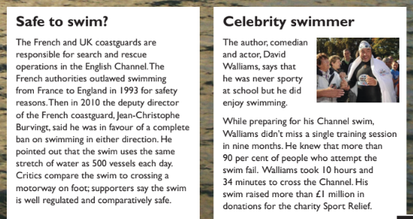
Questions
- Nearly twenty-two hours later, the exhausted man staggered onto French soil
at Calais and became an instant hero.
Find and copy two different words from the sentence above that show how
tired Matthew Webb was.

- What event made Matthew Webb want to swim the English Channel?

- Look at the paragraph beginning: Twenty-seven-year-old Webb...
Find and copy one word from this paragraph that is closest in meaning
to ‘motivated’.

- Name two of the hardships that Matthew Webb faced in swimming the
English Channel and explain how he dealt with them.

- Why do slow Channel swimmers swim further than faster swimmers?

- Look at the section headed: Safe to swim?
Find and copy one word which shows that swimming the Channel is illegal
in France.

- David Walliams was determined to be successful in his attempt to swim the
English Channel.
Give one piece of evidence from the text which shows this.

Grammar
A verb is a word used to describe an action, state, or occurrence.
Verbs can be used to describe an action, that is doing something. For example, like the word ‘jumping’ in this sentence:
The rabbit was jumping in the field.
They can also be used to describe a state of being, that is feeling something. For example, the word ‘likes’ here:
The monster likes rollercoasters.
Or a verb can be used to describe an occurrence, that is something happening. For example, the word ‘became’ in this sentence:
The caterpillar became a butterfly.
Can you answer these questions?

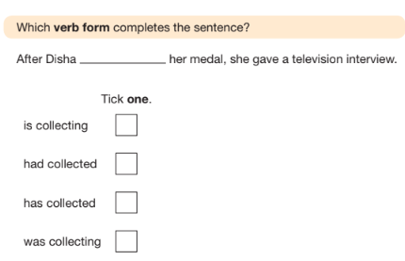

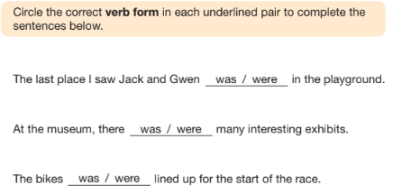

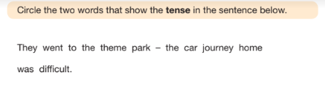

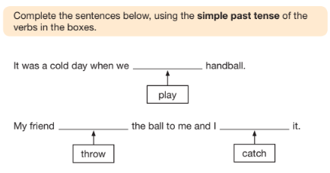

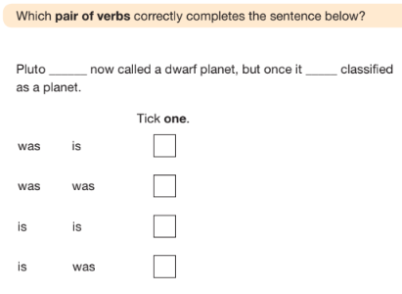

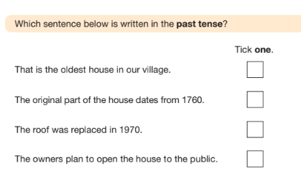

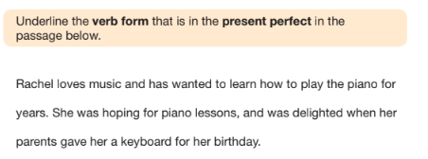
Maths
What is Place Value?
In math, every digit in a number has a place value.
Place value can be defined as the value represented by a digit in a number based on its position in the number.

Please answer these questions:

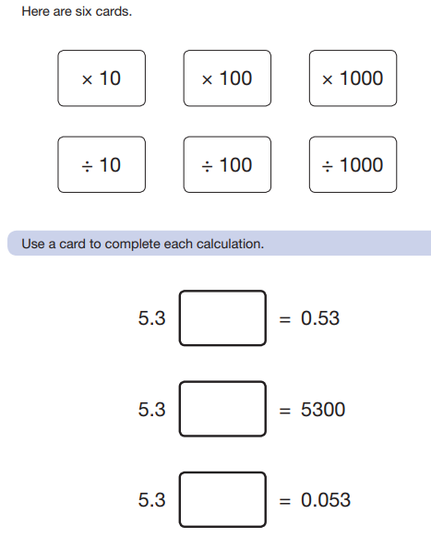

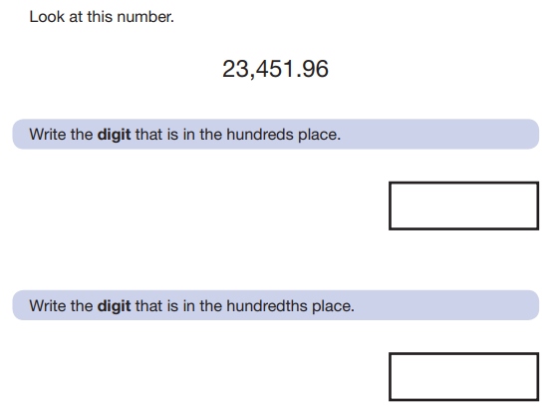

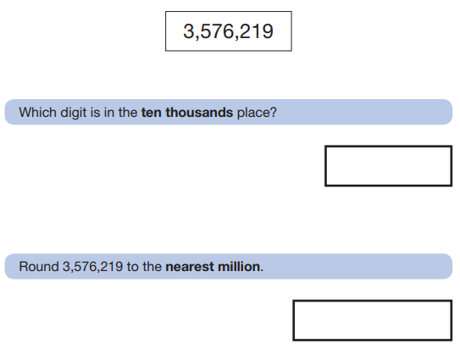

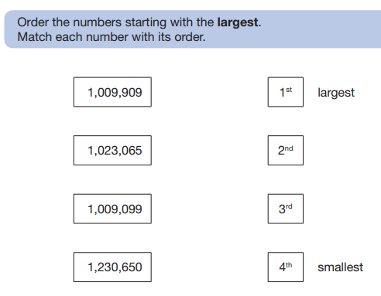

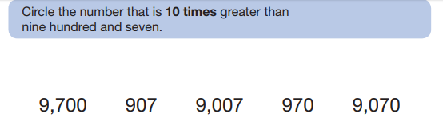

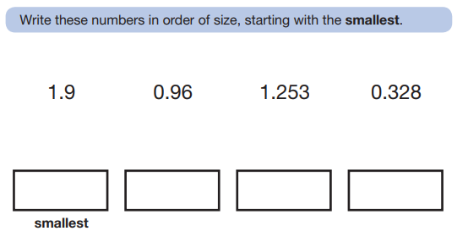

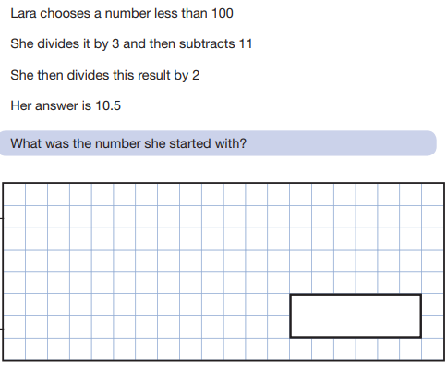
Science
I LOVE SCIENCE!!
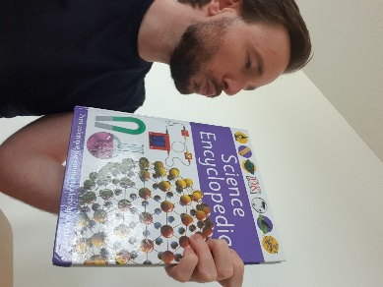
I have placed the links to some ONLINE science lessons that are a FANTASTIC way for you to keep up your development of the subject. Please see the link below:
https://www.stem.org.uk/remote-lessons/key-stage-2
The lessons above, are based around the digestive system, circulatory system, adaption electricity and forces. PLEASE take a look. Each lesson comes with a downloadable worksheet that you can use along with watching the videos.

THE CREST AWARDS
As the Science Lead at Shaftesbury, I have been passionate about celebrating the children’s talents in Science. THE CREST AWARDS are a wonderful way of children working towards a certificate and badge accredited by The British Science Association.
There are links to THE CREST AWARDS in the home learning section of the school website under ‘Science’. I have also, added a link below.
https://primarylibrary.crestawards.org/all-superstar-challenges/61747644
These activities can be completed, and a certificate will be awarded once EIGHT activities are completed.
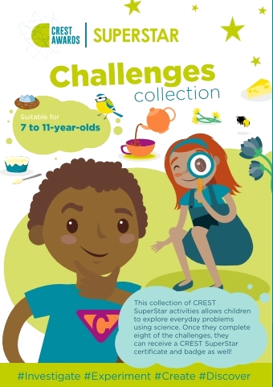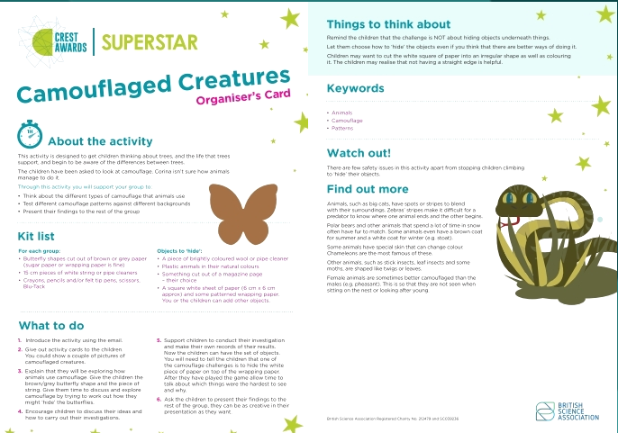

I have provided a CREST AWARDs activity below. Please complete it and start (or continue) your journey towards success.
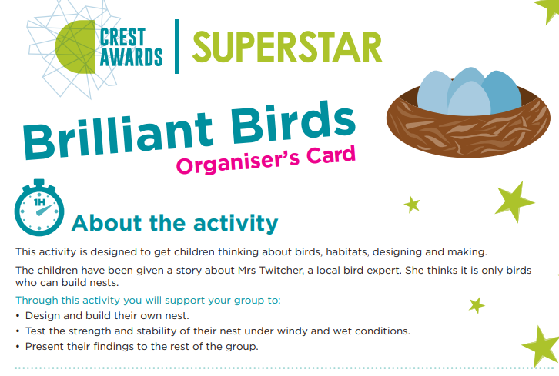
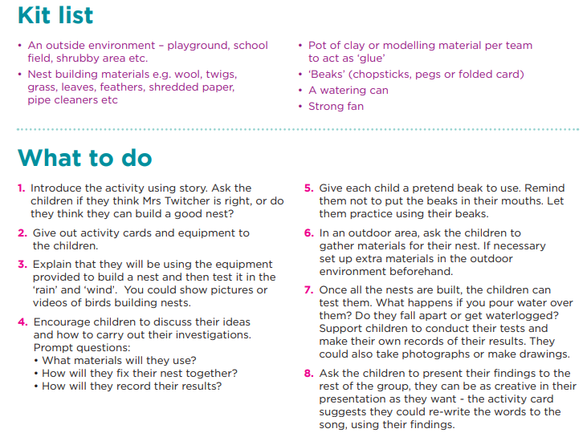

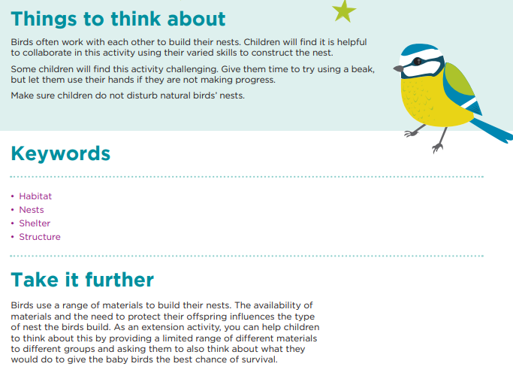
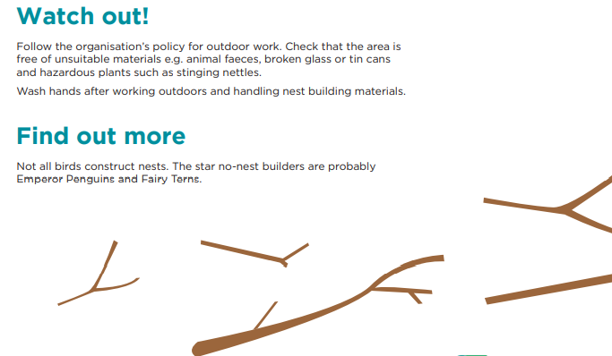

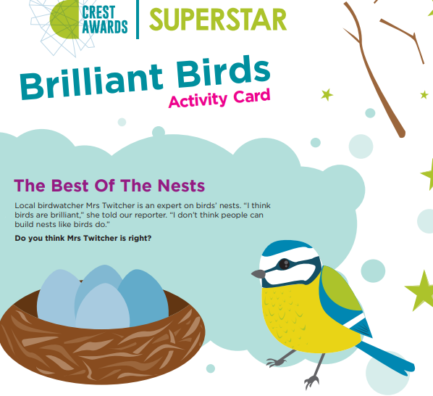
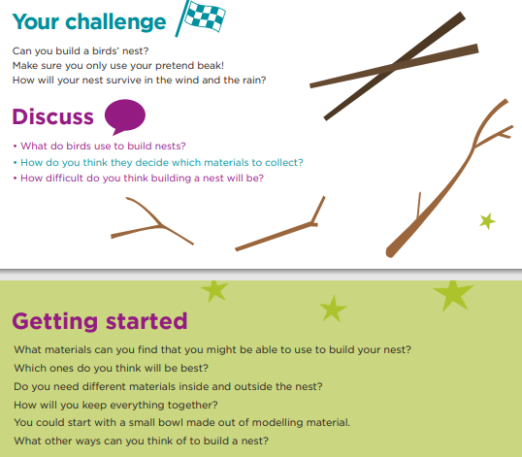

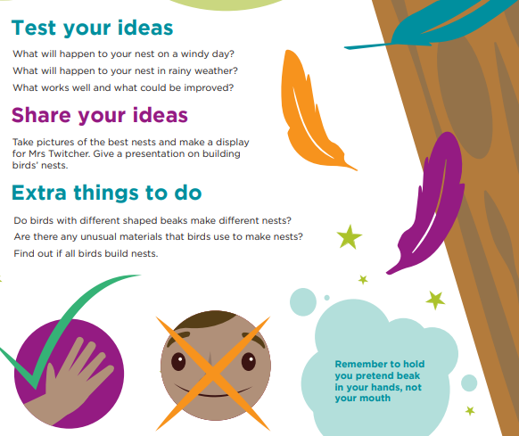

Art
Banksy is an anonymous England-based street artist, political activist, and film director, active since the 1990s. Do you know what ‘anonymous’ means?
His satirical street art combines dark humour with graffiti executed in a distinctive stencilling technique. His work usually reflects subjects that are relevant to the times we are living through
Use a dictionary to look up the word ‘satirical’.
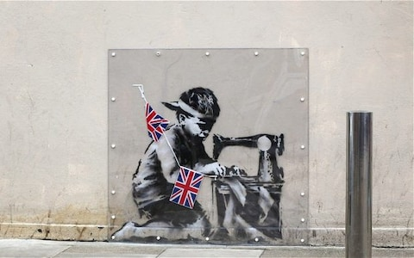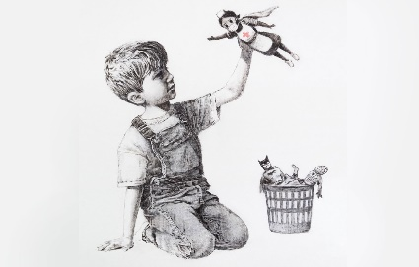
Have you seen these pieces of artwork? What do you think they represent?
Research the work of Banksy and re-create one of his pieces of art.

