The Year Six Transition Newsletter – 24th July 2020

Hello Year 6,
We hope you and your families are doing well once again. For those of you who haven’t read the first of these; we have decided to send you some extra learning over your summer holiday to further help you with your transition into secondary school. This is to make sure, that despite these extraordinary circumstances, you have the best possible preparation for your new school. Please make sure to work over these packs and record your learning in your learning books or on your computers. You can send your work in by taking pictures and sending them via email or doing the same with the documents you create on your computers. We hope that you are still receiving messages and emails from your new schools. Make sure to attempt every piece of learning they send you as well! We continue to thank you for all the great work you have continued to complete over the last few weeks and we’ll continue to keep checking in and seeing what you are up to.
We have stopped updating weekly tasks on Purple Mash since the 17th July. However, make sure to use Serial Mash to continue your reading and comprehension practice.
As well as Purple Mash, we have also been able to give you all access to MyMaths until September. Please take advantage of the tests and activities you may find on the website.
Use the URL: www.mymaths.co.uk and enter our school’s username and password to login.
The school username is: shaftesbury1
The school password is: triangle38
Do not try your old passwords and usernames yet! They will be sent to you at a later date.
As always, take care and keep learning!
Mr Bennett
English
Reading Comprehension – Words in context
This week, we are continuing work on Romeo and Juliet; one of William Shakespeare’s most famous plays.
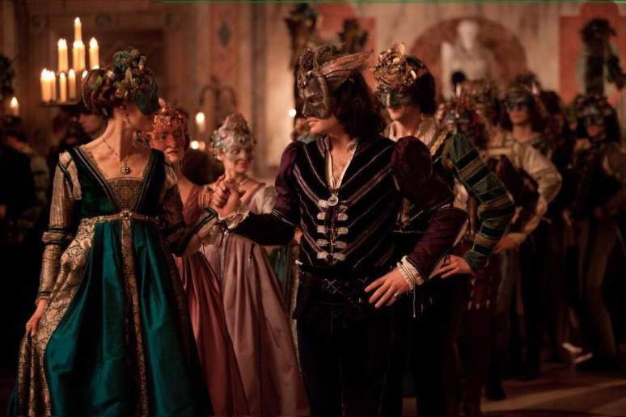
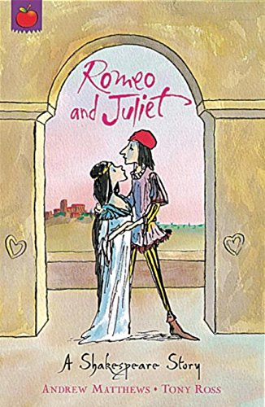

Words in context
To understand unfamiliar words, it’s important to look at the situation they are being used in. Let’s look at a pirate text before we attempt our questions.
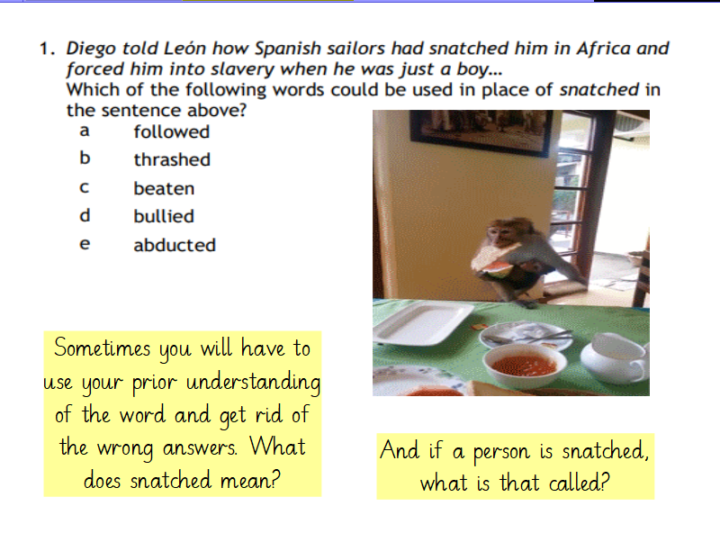
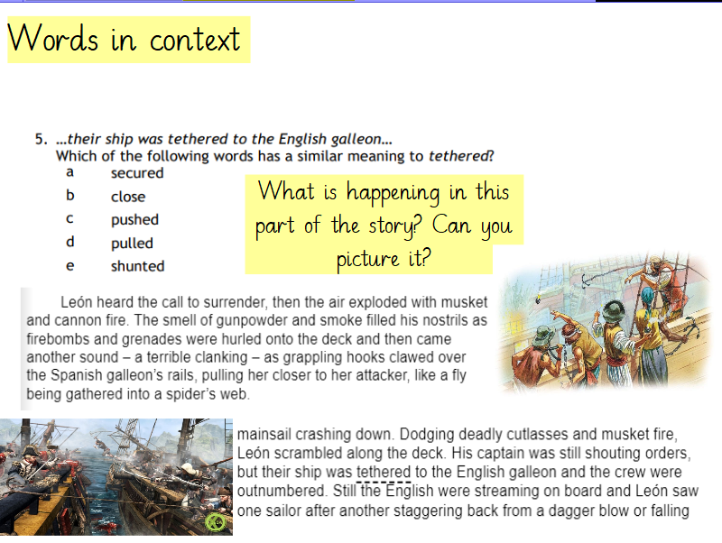

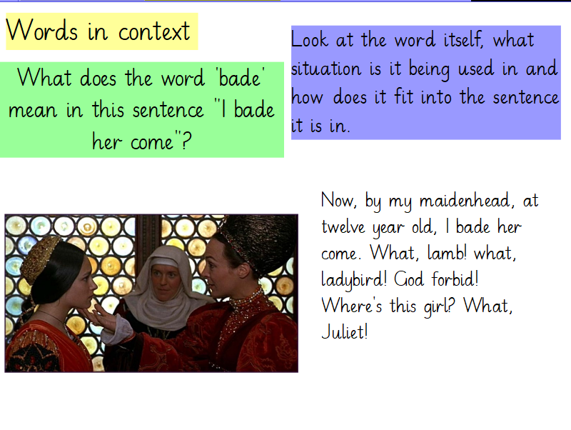

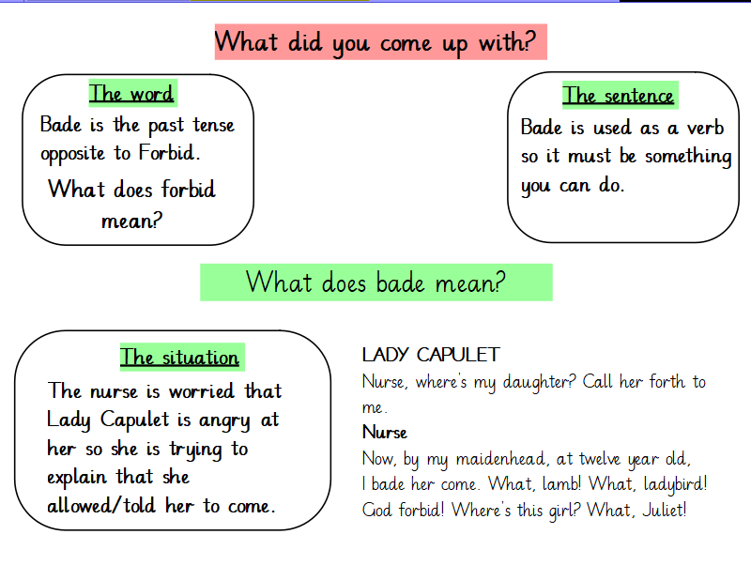
Use these tips to help you read through the text provided and answer some questions.
Since the last scene we read, Juliet has been introduced and Romeo has been scorned by his first love Rosaline. They are now set to meet at Lord Capulet's ball.

SCENE V. A hall in Capulet's house.
Musicians waiting. Enter Servingmen with napkins
First Servant
Where's Potpan, that he helps not to take away? He
shift a trencher? he scrape a trencher!
Second Servant
When good manners shall lie all in one or two men's
hands and they unwashed too, 'tis a foul thing.
First Servant
Away with the joint-stools, remove the
court-cupboard, look to the plate. Good thou, save
me a piece of marchpane; and, as thou lovest me, let
the porter let in Susan Grindstone and Nell.
Antony, and Potpan!
Second Servant
Ay, boy, ready.
First Servant
You are looked for and called for, asked for and
sought for, in the great chamber.
Second Servant
We cannot be here and there too. Cheerly, boys; be
brisk awhile, and the longer liver take all.
Enter CAPULET, with JULIET and others of his house, meeting the Guests and Maskers
CAPULET
Welcome, gentlemen! ladies that have their toes
Unplagued with corns will have a bout with you.
Ah ha, my mistresses! which of you all
Will now deny to dance? she that makes dainty,
She, I'll swear, hath corns; am I come near ye now?
Welcome, gentlemen! I have seen the day
That I have worn a visor and could tell
A whispering tale in a fair lady's ear,
Such as would please: 'tis gone, 'tis gone, 'tis gone:
You are welcome, gentlemen! come, musicians, play.
A hall, a hall! give room! and foot it, girls.
Music plays, and they dance
More light, you knaves; and turn the tables up,
And quench the fire, the room is grown too hot.
Ah, sirrah, this unlook'd-for sport comes well.
Nay, sit, nay, sit, good cousin Capulet;
For you and I are past our dancing days:
How long is't now since last yourself and I
Were in a mask?
Second Capulet
By'r lady, thirty years.
CAPULET
What, man! 'tis not so much, 'tis not so much:
'Tis since the nuptials of Lucentio,
Come pentecost as quickly as it will,
Some five and twenty years; and then we mask'd.
Second Capulet
'Tis more, 'tis more, his son is elder, sir;
His son is thirty.
CAPULET
Will you tell me that?
His son was but a ward two years ago.
ROMEO
[To a Servingman] What lady is that, which doth
enrich the hand
Of yonder knight?
Servant
I know not, sir.
ROMEO
O, she doth teach the torches to burn bright!
It seems she hangs upon the cheek of night
Like a rich jewel in an Ethiope's ear;
Beauty too rich for use, for earth too dear!
So shows a snowy dove trooping with crows,
As yonder lady o'er her fellows shows.
The measure done, I'll watch her place of stand,
And, touching hers, make blessed my rude hand.
Did my heart love till now? forswear it, sight!
For I ne'er saw true beauty till this night.
TYBALT
This, by his voice, should be a Montague.
Fetch me my rapier, boy. What dares the slave
Come hither, cover'd with an antic face,
To fleer and scorn at our solemnity?
Now, by the stock and honour of my kin,
To strike him dead, I hold it not a sin.
CAPULET
Why, how now, kinsman! wherefore storm you so?
TYBALT
Uncle, this is a Montague, our foe,
A villain that is hither come in spite,
To scorn at our solemnity this night.
CAPULET
Young Romeo is it?
TYBALT
'Tis he, that villain Romeo.

Questions
1. What does 'sought for' mean?
2. Why does Capulet mean by 'Will have a bout with you'?
3. What does 'quench the fire' mean?
4. What does Romeo mean by 'enrich the hand of yonder knight'?
5. What does 'yonder' mean?
6. What word could you replace 'storm' with when Capulet is speaking to Tybalt?

Grammar – Adjectives and Adverbs
Attempt the tasks underneath, they will come with explanations.
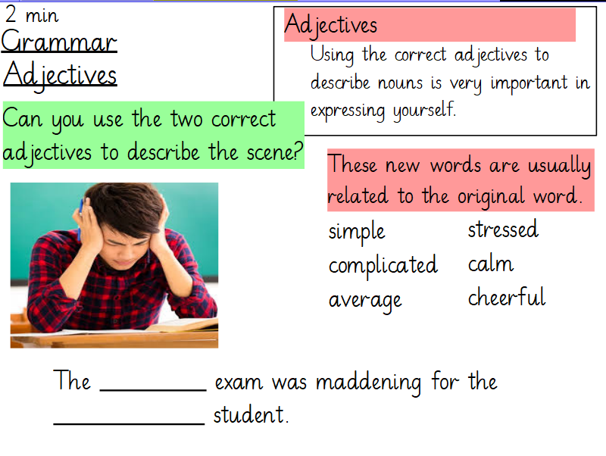

Grammar Task

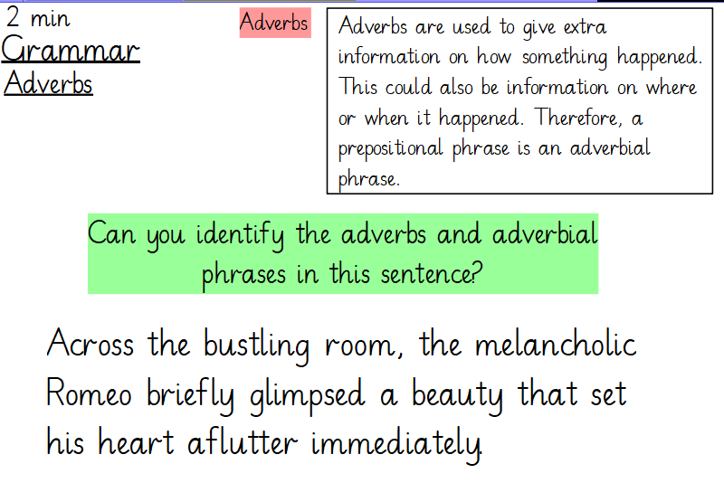
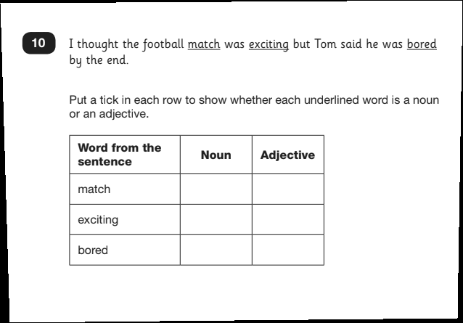
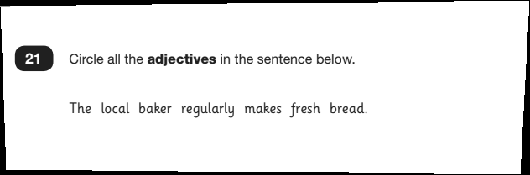
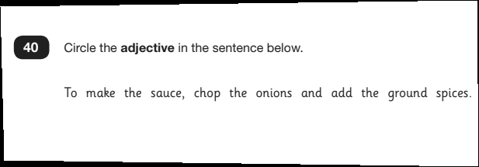
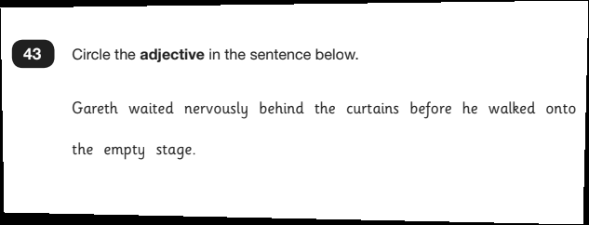
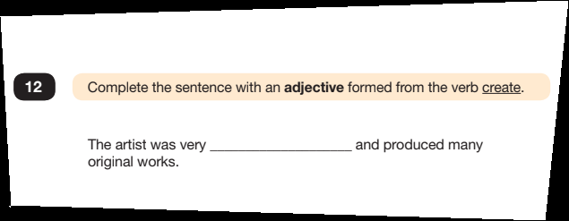
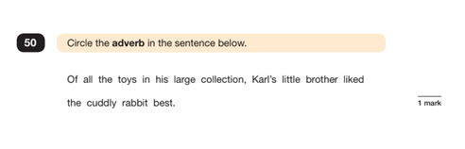
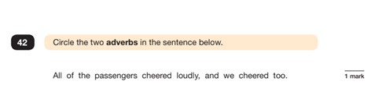
Maths – Revision (Scale and Number sequences)
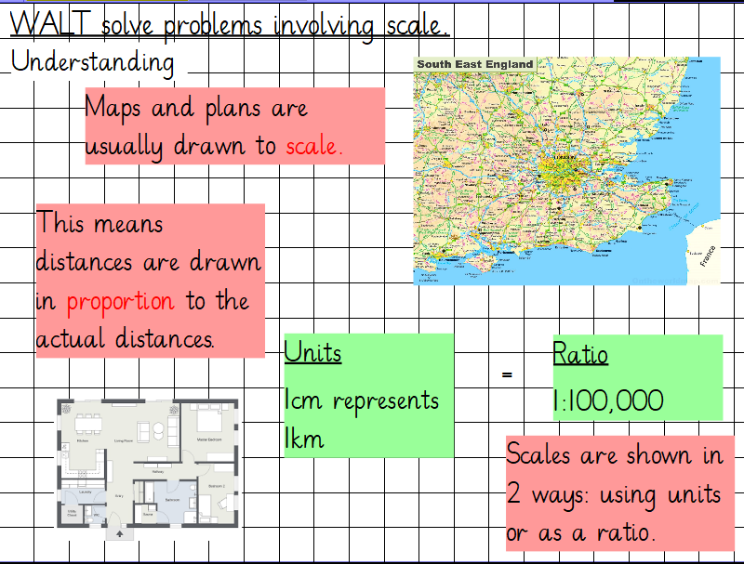

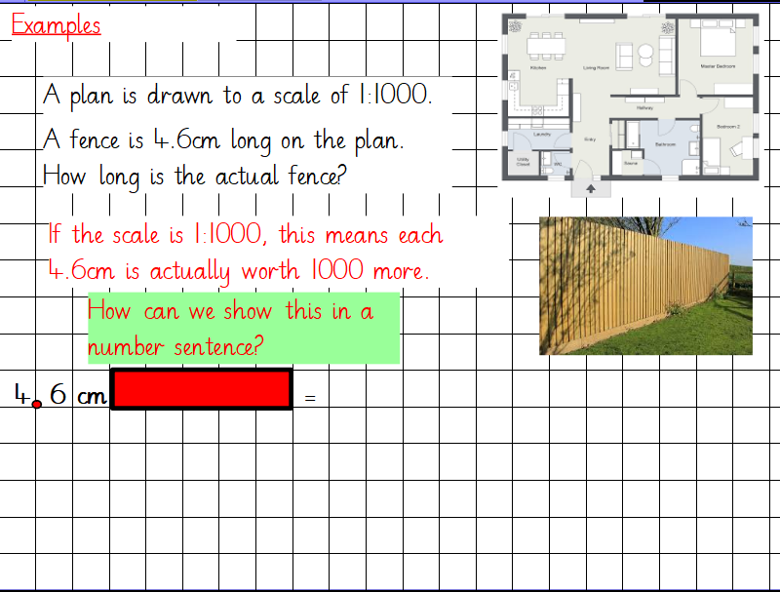

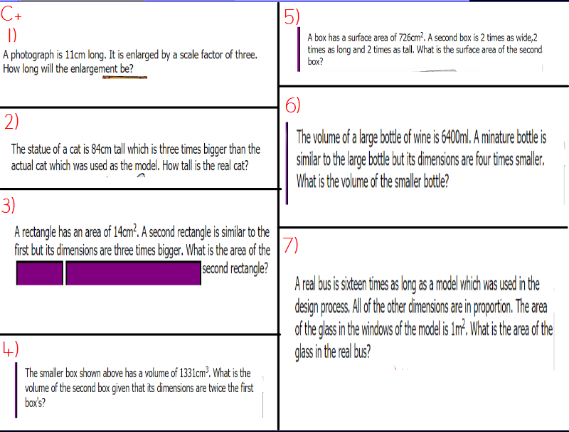

Number sequences
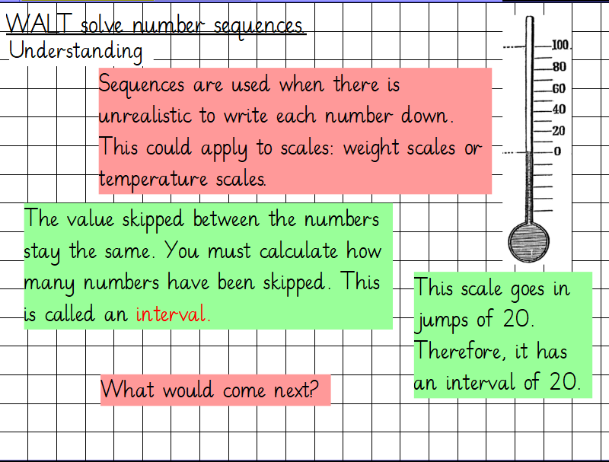

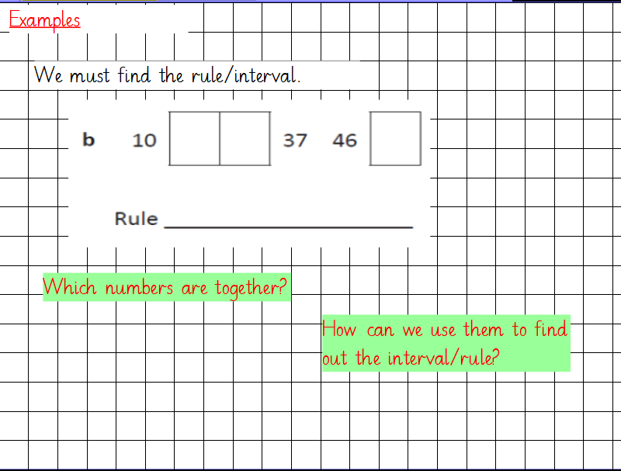

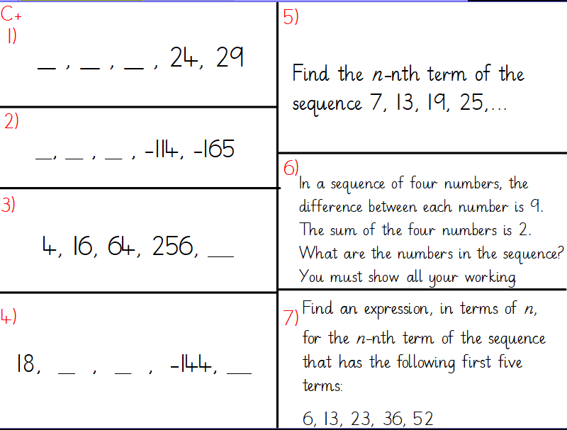

Science – Biology
At secondary school, you will be taught Science based on its three key topics. Biology, Chemistry and Physics. This is the second part of the learning to get you prepared for Science in Year 7, so make sure to go back and see the first part.
Cells and their functions
Cells and their functions
Humans are multicellular. That means we are made of lots of cells, not just one cell. The cells in many multicellular animals and plants are specialised, so that they can share out the processes of life. They work together like a team to support the different processes in an organism.
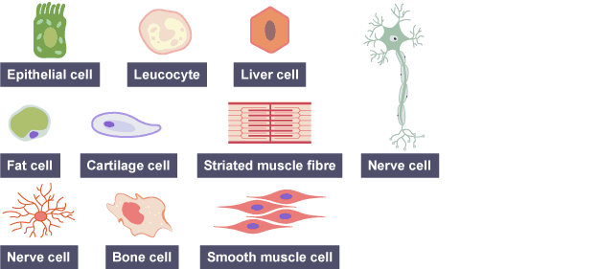

These are examples of some specialised animal and plant cells, with their functions and special features:
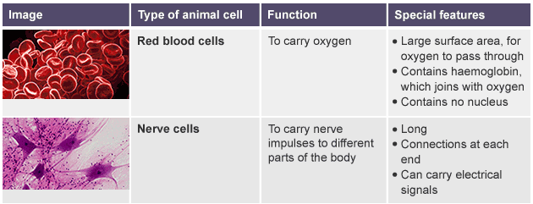
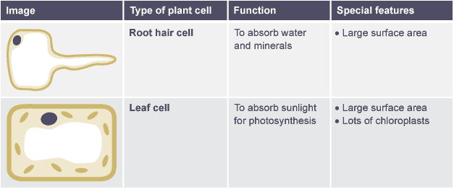
Unicellular organisms
A unicellular organism is a living thing that is just one cell. There are different types of unicellular organism, including:
bacteria
protozoa
unicellular fungi
You might be tempted to think that these organisms are very simple, but in fact they can be very complex. They have adaptations that make them very well suited for life in their environment.
Bacteria
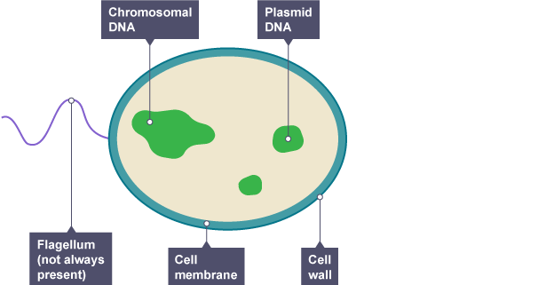
Bacteria are tiny. A typical bacterial cell is just a few micrometres across (a few thousandths of a millimetre). The structure of a bacterial cell is different to an animal or plant cell. For example, they do not have a nucleus but they may have a flagellum. This is a tail-like part of the cell that can spin, moving the cell along.

Protozoa
Protozoa are unicellular organisms that live in water or in damp places. The amoeba is an example of one. Although it is just one cell, it has adaptations that let it behave a bit like an animal:
it produces pseudopodia (“false feet”) that let it move about.
its pseudopodia can surround food and take it inside the cell.
contractile vacuoles appear inside the cell, then merge with the surface to remove waste.
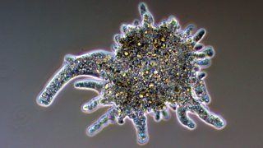

Yeast
You may be familiar with fungi from seeing mushrooms and toadstools. Yeast are unicellular fungi. They are used by brewers and wine-makers because they convert sugar into alcohol, and by bakers because they can produce carbon dioxide to make bread to rise.
Yeast have a cell wall, like plant cells, but no chloroplasts. This means they have to absorb sugars for their nutrition, rather than being able to make their own food by photosynthesis
Yeast can reproduce by producing a bud. The bud grows until it is large enough to split from the parent cell as a new yeast cell.
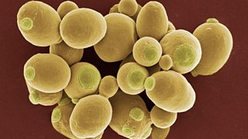

Science Test
Try these questions.
  - Name three types of cells humans have in their bodies.
  - What is the function of a leaf cell?
  - What is a unicellular organism?
  - Does bacteria have a nucleus?
  - What features allow protozoa to behave like an animal?
  - How does yeast reproduce?

