Good morning 6E,
Without doubt, I can imagine that this has been an uncertain time for you and one that none of us could have predicted when we began our journey together back in September. If I consider all the Year Six classes I have taught over the years, then you are certainly some of the most hard working I have had the pleasure of teaching and I hope that I get the opportunity to work with you once more in the near future.
In terms of the last few weeks, I have been working from home and planning lessons that are for your benefit, once we can return to Shaftesbury. Although it is much quieter at home, I do actually miss some of your ‘jokes’ and ‘funny’ comments (that is something I thought I would never say).
As well as planning lessons, I have begun to pursue a passion for artwork, while spending more time at home. Do you remember Roy Lichtenstein? We created some self-portraits at the beginning of the year that used his ‘ben day dot’ effect. My example is a contemporary twist that pays homage to the fantastic work the NHS are doing to protect us all. What does ‘contemporary’ and ‘homage’ mean?
Furthermore, I have begun to grow herbs in my flat (see below) to develop my gardening skills. I am growing chives, basil and parsley. The Basil is already beginning to grow and hopefully in a few weeks I can pick the leaves and use it on my pizza! These are all examples of herbs and we tend to use them to season our food. Can you name any others?
So…What have you been up to? Please send an email to the school and show me how you have been keeping busy (and not just sitting on the PS4). Have you been helping around the house? Cooking? Baking? Home improvements?
I know these are difficult times but remember that this situation will pass, and you will soon be able to get back to normal (playing with your friends, going back to school and getting a haircut, haha!). I encourage you to KEEP USING purple mash and using my CREST AWARD SCHEME for Science that you can find on the school website. I will keep monitoring it, so I can help you.
Stay happy and healthy!
Mr Everard

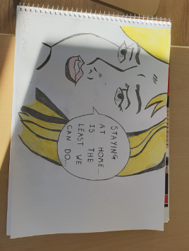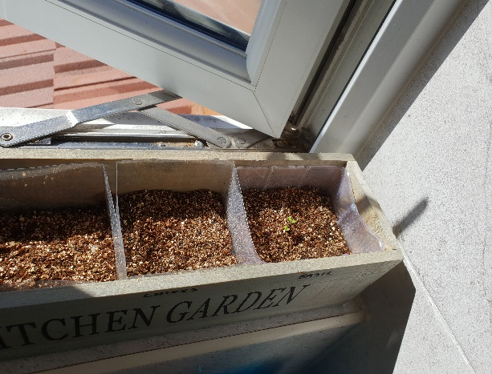
My version of Roy Lichtenstein’s pop art. My ‘Kitchen Garden’
Artist: J.Everard – ‘The NHS’ Can you see the basil?

