The Year Six Newsletter – Week 6

Hello Year 6,
We hope you and your families are well and you’ve been able to enjoy your summer holidays. We have one final newsletter with lots of activities to keep your brains active before you start secondary school next week.
We hope you have completed the transition packs ready for your September start. If you have not, please visit: https://www.shaftesburyprimaryschool.co.uk/page/?title=School+Closures&pid=101 alternatively when on the Shaftesbury website visit- Parents- School Closure- Year 6 Transition.
Once again, it has been a pleasure teaching you this year. We wish you all the best for your new year to come. We hope you make lots of friends, create lots of fun memories, experience new things, learn and grow within yourselves and most of all enjoy every moment of secondary school. Goodbye and good luck from the entire Shaftesbury Team!
Ms Foster, Mr Bennett, Mr Everard
English
Reading Comprehension
Please read the facts about William Shakespeare.
William Shakespeare
William Shakespeare is world famous. We know quite a lot about him, but there is still much that remains a mystery. We don’t know his date of birth. We don’t know the date of his marriage. We even have very little idea of what he looked like. So what do we know about William Shakespeare, the man?
When and where was Shakespeare born?
William Shakespeare was born in 1564 in Stratford-upon-Avon, a market town in a farming area of the Midlands. About 1000 people lived there. Shakespeare, England's greatest writer, may have been born on St. George’s Day: he was baptised on 26th April, so it is possible, but we really don’t know. It would be fitting, as he also died on the day of England’s patron saint – St George’s Day – 23rd April.

What was Shakespeare’s family like?
William was born to prosperous parents. His mother, Mary, was the daughter of a local farmer. His father, John, was a glove-maker and wool trader with a large family house. When William was four years old, his father was elected Bailiff of Stratford – effectively the mayor.
But his early life wasn’t easy. Although William was the third of eight children, he grew up as the oldest. His two older sisters both died very young. And William was lucky to survive. When he was just a baby, in 1564, plague killed about 200 people in Stratford – 1 in 5 of the population. Fortunately, William survived.

When did Shakespeare marry?
In late 1582, we don’t know the exact date, Shakespeare married Anne Hathaway – a local farmer’s daughter. William was only 18 years old. Most men at this time married in their mid- to late-20s. So why did William marry so young? The answer came six months later, when William’s daughter, Susanna, was baptised.

What do we know of Shakespeare’s family life?
The answer is… practically nothing. We know William and Anne had two more children, Hamnet and Judith, twins, born in 1585. Anne and the three children probably lived with William’s parents at first. Later, they moved to New Place, a large house in Stratford. But it was a strange family life. Shakespeare spent most of his time 100 miles away, in London.

Where did Shakespeare go to school?
From the age of seven, boys like William went to grammar school. There was one in Stratford and it is still there today. But schooling was different then. The boys learned to read, speak and write in Latin. They also had to memorise and perform stories from history - useful skills for an actor and writer. Shakespeare probably left school aged fifteen.
We have six surviving versions of Shakespeare’s signature. They are all different. He wrote: Willm Shakp; Wm Shakspe; Willm Shakspere; William Shaksper; Willm Shakspere; William Shakespere; and William Shakespeare. The last version, taken from his will in 1616 is the version we use today.

What did Shakespeare do in London?
From about 1590 to 1613, Shakespeare lived mainly in London and by 1592 was a well-known actor there. He was also a playwright. His play, Henry VI, was performed at the Rose theatre in 1592. He went on to write, or cowrite, about 40 plays. Shakespeare was also a poet and in 1609 published a book of 154 sonnets.
And Shakespeare was a businessman too. He was a sharer (part-owner) of a theatre company called The Lord Chamberlain’s Men. And from 1599, he was part-owner of the Globe Theatre. So, for about twenty years, he made money from acting, writing and running a theatre company.

When did Shakespeare die?
After 1613, Shakespeare spent more time at Stratford. Then, in January 1616, he made a will and died on 23rd April 1616. He is buried in Holy Trinity church in Stratford-upon-Avon.

Writing Plays
An English traveller of the time wrote, “…there be more Playes in London than in all the partes of the worlde I have seene.” A modern historian estimates that, between about 1560 and 1640, some 3000 new plays were written and performed in London.

Who wrote the plays?
William Shakespeare has become the most famous playwright of his time. He wrote or co-wrote almost 40 plays. But he was one of many writers producing plays in London at that time. The best known of the others are Christopher Marlowe and Ben Jonson. The grammar schools which boys like Shakespeare attended taught useful skills for playwrights. They memorised the history and myths of Ancient Greece and Rome; they wrote their own stories and recited these to classmates. Many playwrights also went to university. For example, Marlowe went to Cambridge. But some playwrights did not - like Shakespeare and Jonson for example. They probably learned the skills of writing plays whilst working as young actors.

What were the plays about?
Playwrights at this time were not too bothered about being original. They were content to re-work old stories or even use other people’s plots. Shakespeare’s The Taming of the Shrew was a re-write of an earlier play and The Comedy of Errors was based on a plot from an ancient Roman writer named Plautus.
Plays usually fell into three types:

Histories were stories about England’s past. Marlowe wrote Edward II, while Shakespeare wrote plays about King John, Henry IV, Henry V, Henry VI, Richard III, and Henry VIII. His first play about Henry VI was so popular that he wrote a sequel and then a prequel.

Tragedies told unhappy tales which often ended in deaths, like Shakespeare’s Romeo and Juliet. John Webster had a big hit with The Duchess of Malfi and Shakespeare is famous for Othello and Hamlet. Like today, playwrights in Shakespeare’s time sometimes used blood and horror to entertain the crowds. In Shakespeare’s Titus Andronicus, two characters, Chiron and Demetrius have their throats cut onstage, are cut up and baked in a meat pie, and then their mother is tricked into eating the pie!

Comedies, on the other hand, could be relied upon for happy endings, often weddings. Shakespeare’s Two Gentlemen of Verona is especially happy; it ends with two weddings! Other comedies were more satirical. Ben Jonson wrote The Alchemist to make fun of London society.
But playwrights had to be careful of who or what they made fun of. The Master of the Revels was an official of the royal court and it was his job to grant licenses to theatres, theatre companies and plays. He would not license a play (give it permission to be performed) if it had political or religious views he didn’t like. Playwrights could not risk offending him. So they often set their plays in imaginary countries to make sure that nothing in the plot seemed critical of the royal court or the government.
Questions
1) What don't we know about Shakespeare?
2) What does the word mystery mean?
3) Where and when was Shakespeare born?
4) Did Shakespeare come from a large town? How do you know?
5) What is Shakespeare referred to? What is he known as?
6) Use a dictionary. What does the word prosperous mean? Then, use it in a sentence.
7) What did his father do?
8) Although he wasn't, why did he grow up as the eldest child?
9) Why was he lucky to survive?
10) Why was it fortunate that William survived?
11) Name at least two tradegies Shakespeare wrote
12) What comedy play did Shakespeare write?
13) What would a play license allow people do?
14) Who gave play licenses?

Challenge questions.
1) How do you know there was a lot of plays in London between 1560 and 1640?
2) How many plays did Shakespeare have involvement in the writing?
3) What skills were taught in Grammar schools?
4) Why did Shakespeare do well in this industry?
5) Why didn't Shakespeare need to go to university to become a playwright?

Grammar – Subjects, objects and passive voice.
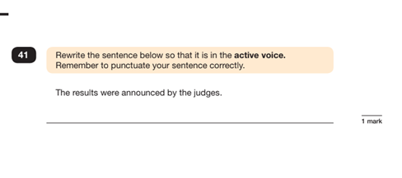
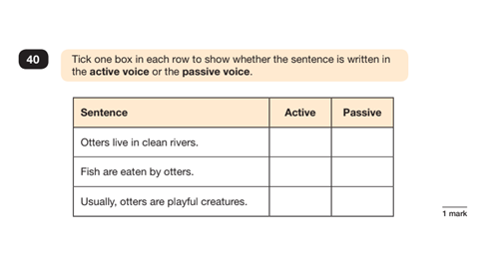
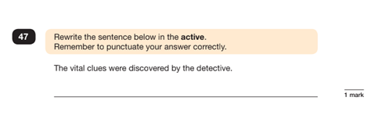
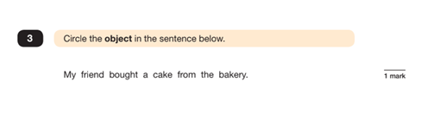
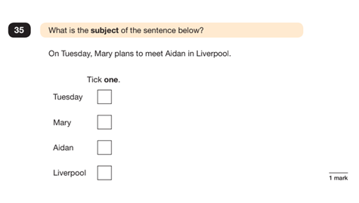
Writing time

Imagine you are William Shakespeare. Write 3-5 Diary entries, from different ages within his life.
Write at least 3 separate diary entries (a minimum of 3 different times in his life)
Have you written in the past tense? Have you included detail? Have you wrote about how he is feeling? What are his future hopes?
Have you used descriptive language? Fronted adverbials? Relative clauses? Rhethorical questions?

Challenge: Can you create a story/ playscript based on the style of William Shakespeare?

Sentence challenge!
Can you use semi-colons to join two independent clauses together?
Can you create interesting noun phrases?
Can you use subordinate conjunctions to start sentences?
Can you use adverbs in a range of different ways throughout your writing?
Can you edit your writing and make it better?

Maths – Fractions.

Warm up
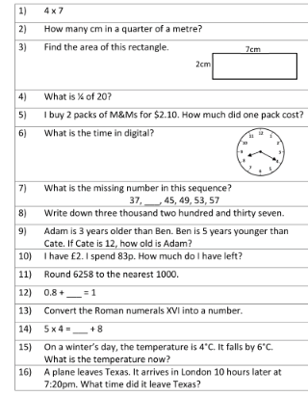
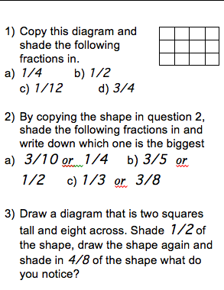

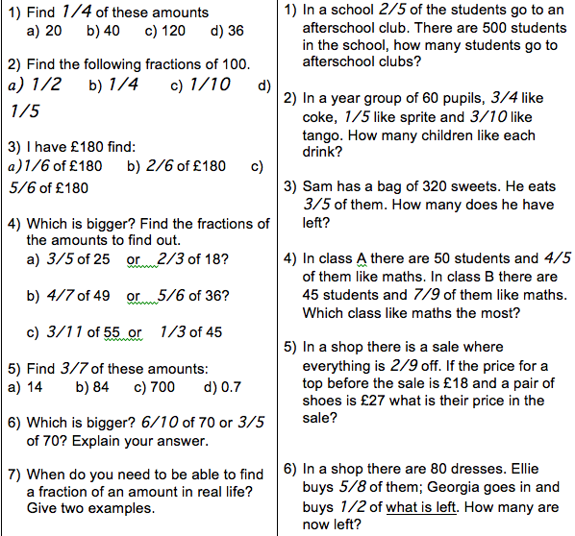

Science
Experiment with pennies, create a rainbow and make edible chocolate slime (Yes, you read that right, edible chocolate slime… yummy).

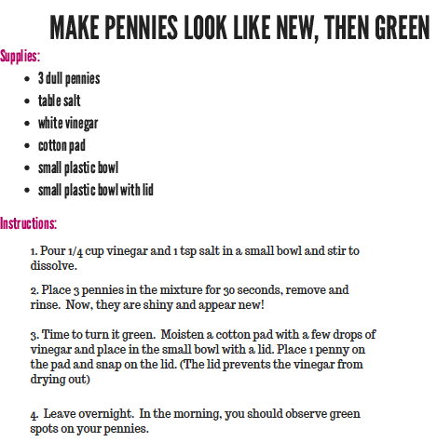
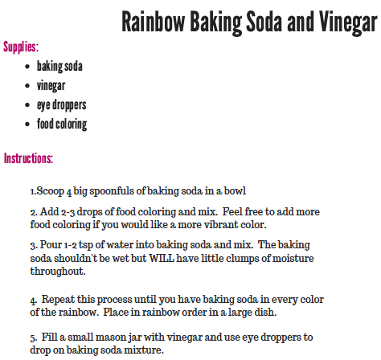

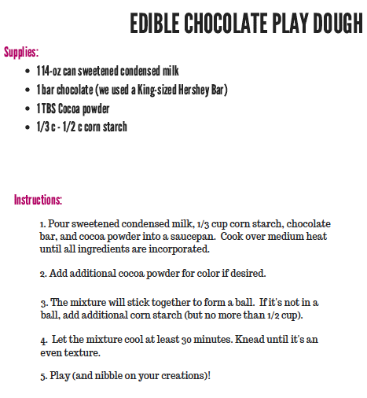
P.E
Stay active at home. Create a fitness circuit in your bedroom, living room or use outdoor space. Think about your P.E lessons; what exercises can you do to get your heart beating fast and blood travelling faster around your body?

Art/ DT – Recycle project! Two week project.

Continue your recycle project from last week.
Look at the following designs for inspiration. Can you find any other items around your home that you can recycle and use within your design. Be as creative as you can be! Good luck and it would be great to see some

