Reception Homework – Friday 13th November 2020
This week we have been learning about Diwali and celebrations. If you celebrate Diwali, can you draw a picture or stick a picture in to show us what you do to celebrate Diwali. If you do not celebrate Diwali, what do you celebrate? You can draw a picture or stick a picture in to your homework book.

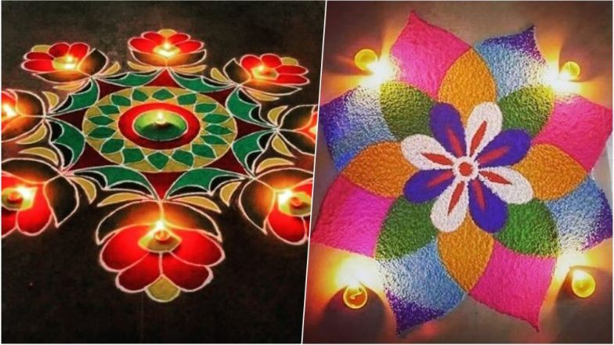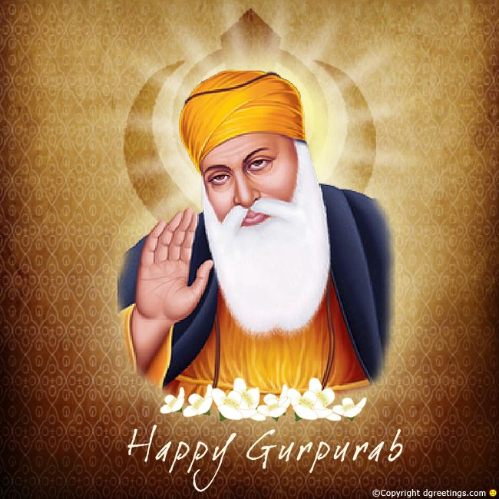

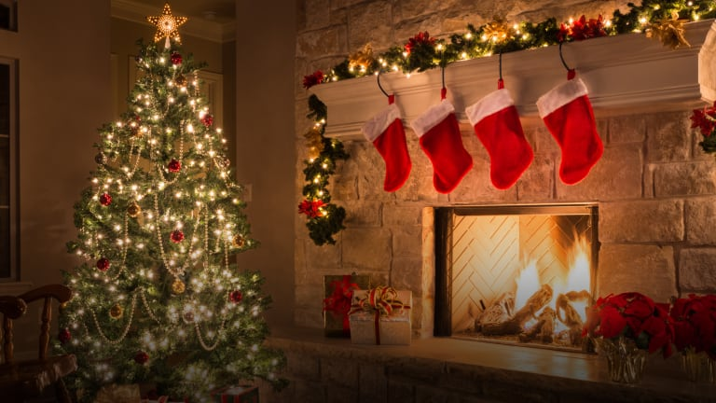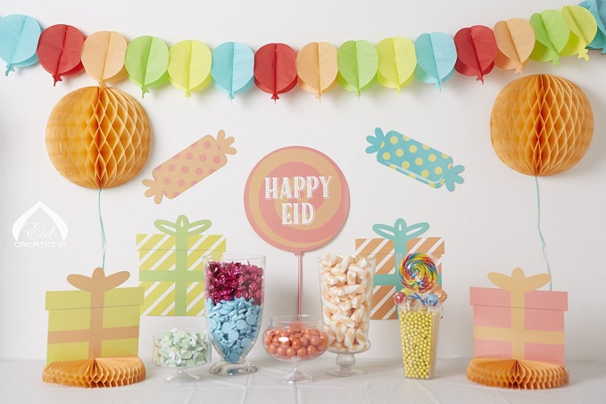

Can you write a sentence for your picture?
You can use the sentence starters:
I celebrate…
I celebrate it by…

