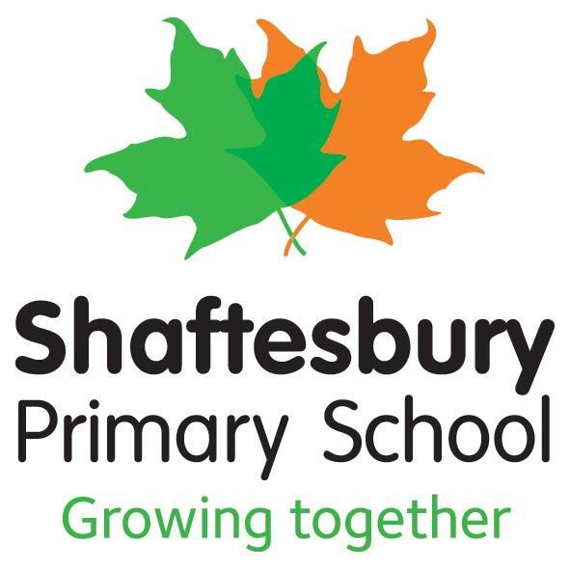
Policy title | : | Assessment Policy
Date approved | : | September 2021
Review date* | : | September 2023
*Please note that should any further national guidance be issued by external agencies that are relevant to this policy, it will be updated accordingly prior to the review date shown above and re-circulated.

Assessment Policy
This policy outlines the fundamental aims which underpin all assessment at Shaftesbury Primary School.
At Shaftesbury, assessment is an ongoing process which supports teachers to modify their teaching in order to improve pupils’ performance and attainment. This is completed through a continuous process of questioning and feedback that allows children to deepen their learning and thinking processes. Children are encouraged to self-reflect and edit their own work. This is done through self-assessment at the end of each lesson. Pupils have regular interactions with teachers who will give feedback and help to guide them to be independent using open questions.
Within our school, there are two main types of assessment:
- Assessment for learning (formative assessment) is the process of seeking and interpreting evidence for use by learners and their teachers to decide where the learners are and where they need to go and how best to get there. Various AFL strategies are used daily to inform teacher assessment and planning:
  - Questioning. Open-end questions aimed at developing a deeper understanding of learning and getting the children to make links cross curricular and with previous learning.
  - Verbal feedback, which engages and encourages positive dialogue, which allows children to be supported, encouraged and challenged.
  - Written feedback with a red pen that focuses on the child’s success and next steps. The red pen will be read and reflected on by the children with their green pen.
  - Steps to success being displayed at all times. This allows children to reflect on the lesson objectives throughout their learning time.
The key strength of our system is the assessment cards which are accessible to both teachers and pupils. Both teachers and children fill in target cards highlighting targets children have met and targets that require further action points. This then informs summative assessment.
- Assessment of learning (summative assessment) provides a summary of what has been learned in regard to both attainment and achievement at a specific point in time. We use summative, test based, assessments to support our formative assessments of the children. At Shaftesbury, we have five Progress Weeks. Three times a year data is inputted using Sims Capita our school devised assessment tracking system. This ensures all data is securely held and linked to pupils.
Pupils are assessed through:
  - Weekly spelling tests (age-appropriate spellings)
  - Weekly Maths multiplication tests (Knight of the Times Tables)
  - Termly PIRA assessments for Reading
  - Termly GAPS assessments for grammar
  - Termly Maths assessment
  - Termly Practise SATs Papers (Year 6) to include past papers. Baseline SATs test is taken at the beginning of the year to measure progress but also for teachers to identify units of work that require more focussed teaching.
  - Half-termly written pieces in English designed to showcase the skills that the children are currently using in their written work. In Year 6, end of KS2 writing descriptors are used.
  - Year 1 phonics test takes place in the summer term focusing on the application of learnt phonic sounds into real and tricky words.
  - Year 2 Statutory Assessment Tests (SATs) take place in the Summer term.
  - Year 4 Multiplication Tables Check (MTC) – to begin academic year 21/22.
  - Year 6 Statutory Assessment Tests (SATs) take place in the Summer term.
  - Baseline assessments - completed at the beginning of both Nursery and Reception to know what strands children are working within in the EYFS curriculum. This helps us to target where they need assistance and informs future planning.
  - NFER tests at the end of the academic year for Years 3-5.

After each term, data is then analysed into different areas. Closing the Gap (CTG) sheets- highlight gaps in the learning between groups of learners. Our context sheets show key demographics for our school and this is discussed during Pupil Progress Meetings (PPMs) for individuals, groups and classes with the Senior Leadership Team.

Focus groups in these sessions are:
  - Pupil Premium Children (PP)
  - More Able (MA)
  - More Able Disadvantaged (MAD)
  - Mid Phase Admissions
  - Lowest 20%
  - English as an Additional Language (EAL)
  - Special educational needs (SEN)
  - Safeguarding concerns
  - Pupils who have not made the SPS scores
There will also be focuses linked to the school development plan. Teachers will need to be able to justify their assessments of the children explaining how they will help children who are not on track and the SLT will support them to achieving this. Intervention groups are then set up to either diminish the difference between certain groups of learners or boost higher achievers.
Foundation assessment
- Assessment for learning (formative) is a key part of our approach to teaching foundation subjects at Shaftesbury Primary School. Staff use their steps to success to quality mark pieces of work. This informs teachers on how to consolidate or challenge a child’s understanding based off their written outcomes. Ultimately, the marking informs future planning and highlights successes, as well as potential areas for improvement.

- Assessment of learning (summative) is rigorous at Shaftesbury Primary School. At the end of each half term, children complete a ‘Progress Week’ from EYFS to year 6 which checks and consolidates their learning against targets and goals for the units of work across foundation subjects. These targets are displayed in pupil’s books, so they have complete autonomy over their progress and ownership of the objectives they are looking to accomplish by the end of each unit. From a teacher’s perspective, the outcomes allow them to consider future planning, so that gaps in children’s knowledge can be addressed.
At Shaftesbury, we have the highest expectations for our pupils to achieve in all areas of the curriculum therefore assessment processes and procedures are reviewed and reflected upon continuously.

