The Year Six Homework Letter
Spellings
Trade_____________________________________________________________
Cycle______________________________________________________________
Grime_____________________________________________________________
Fade_______________________________________________________________
Create_____________________________________________________________
Fame______________________________________________________________
Tickle______________________________________________________________
Persuade___________________________________________________________
Can you find synonyms for these words?
Can you put them into sentences?
English
Reading comprehension
This is an extract taken from ‘Goodnight Mr Tom’. It shows the meeting between Tom Oakley and William Beech for the first time.
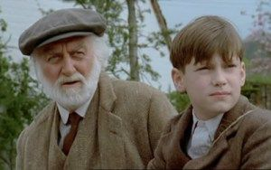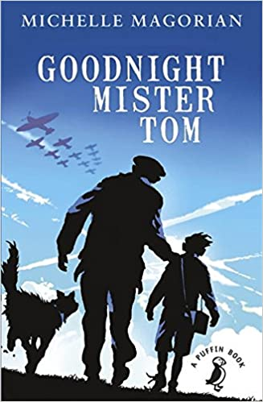
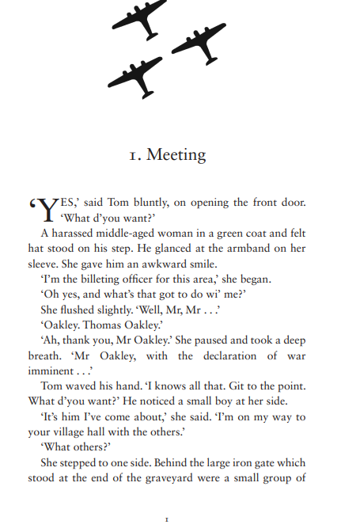
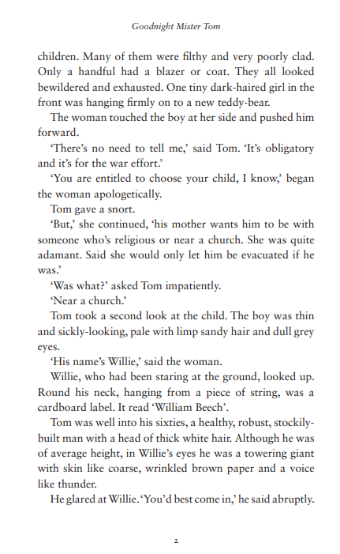
Reading Comprehension

What does the word ‘bluntly’ tell you about Tom’s tone of voice?
Can you find out what a ‘Billeting Officer’ is?
How do we know the Billeting Officer was nervous when speaking to Tom?
Find two pronouns in the extract.
Find the word that is closest in meaning to tired.
What does ‘obligatory’ mean?
How does the author describe Willie’s appearance?
What was put around Willie’s neck?
Did Tom want to take an evacuee? Explain your answer.
Why were children evacuated during World War Two?
When was World War Two?
Why was the countryside safer than the city during World War Two?

Grammar
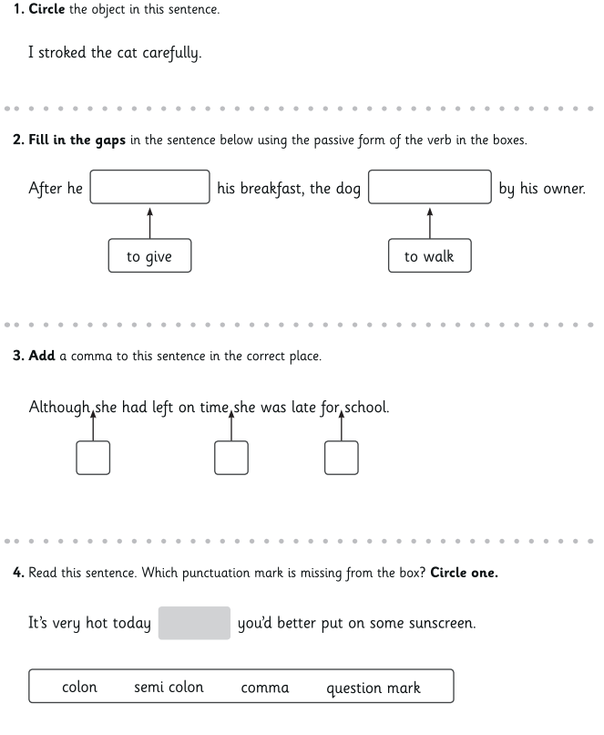
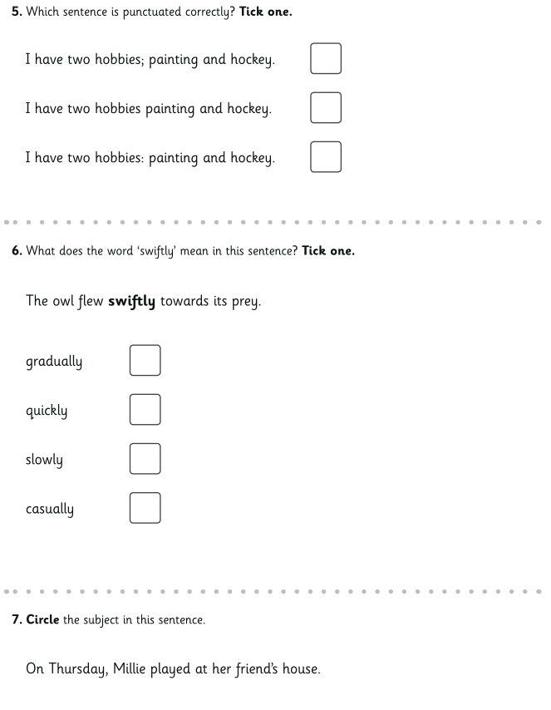
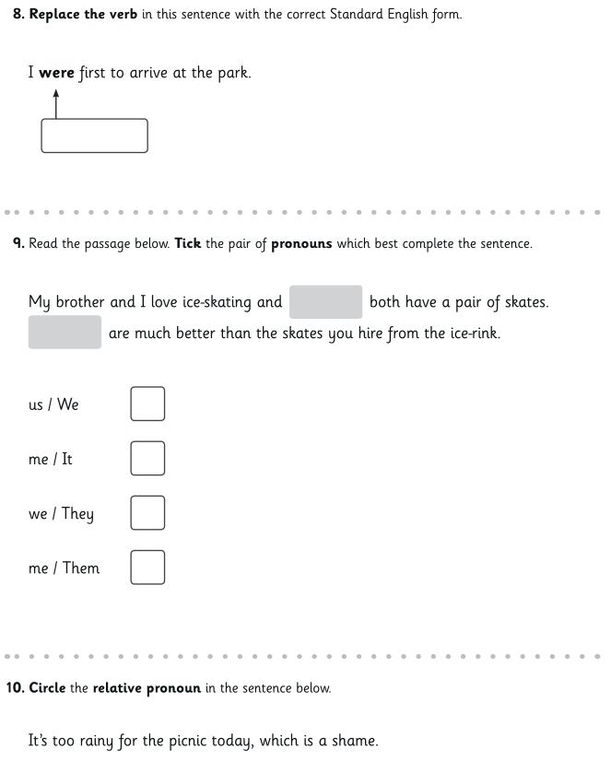

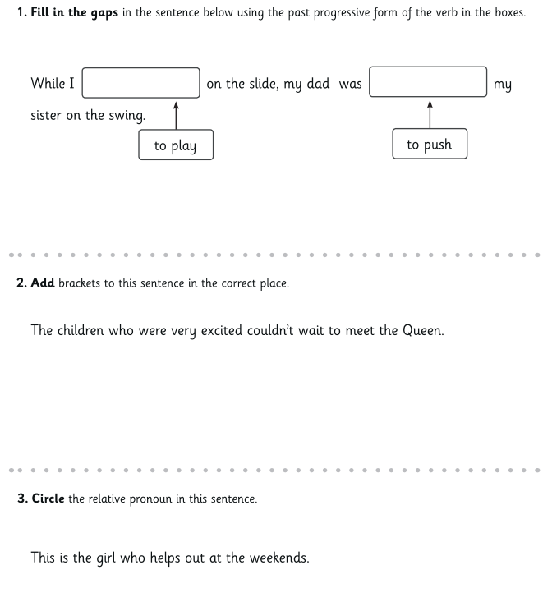
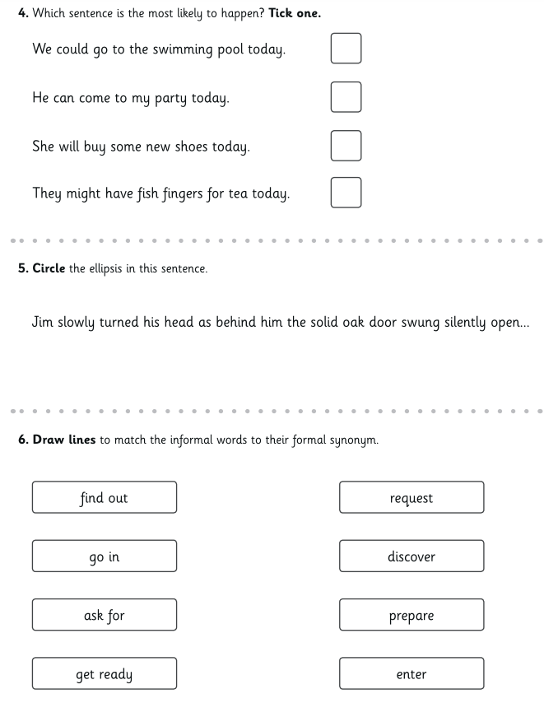
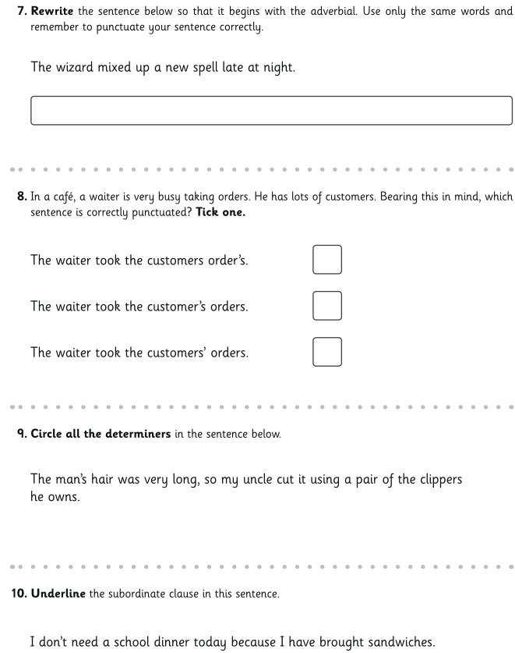

Maths
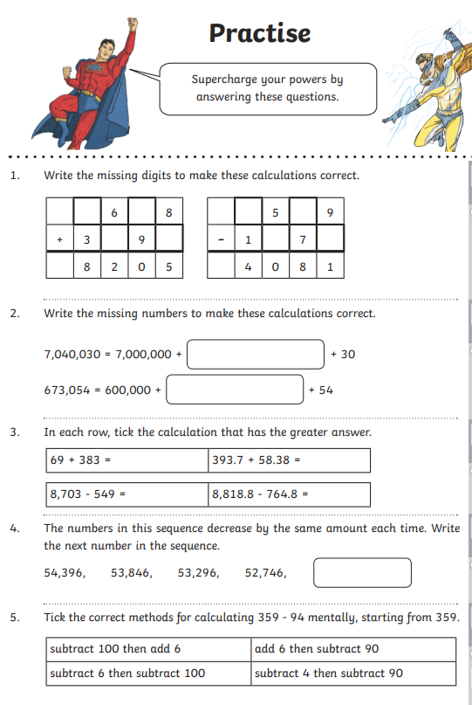
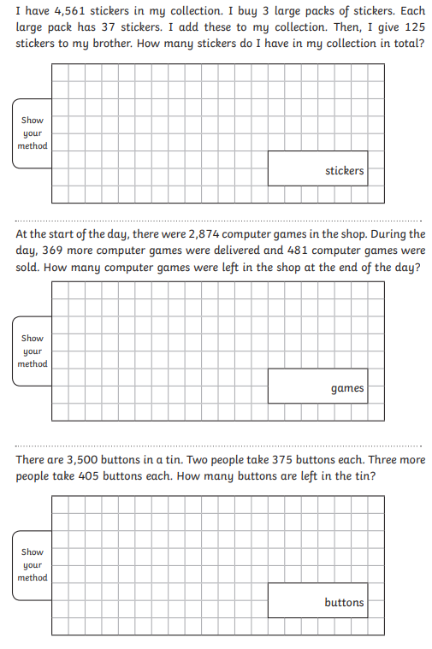

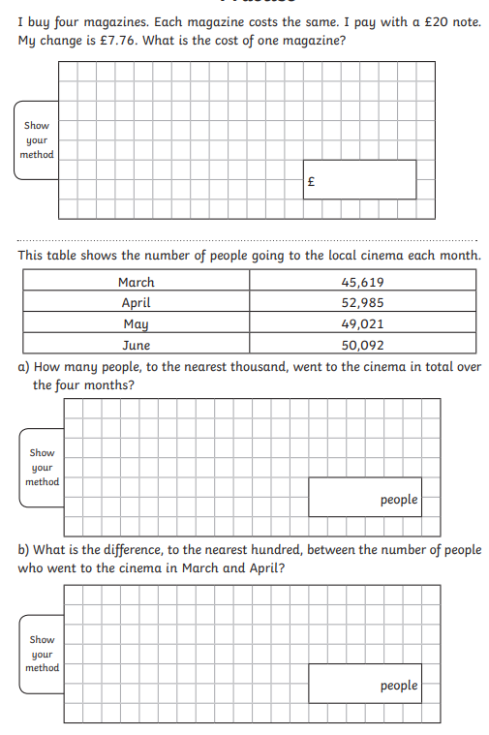
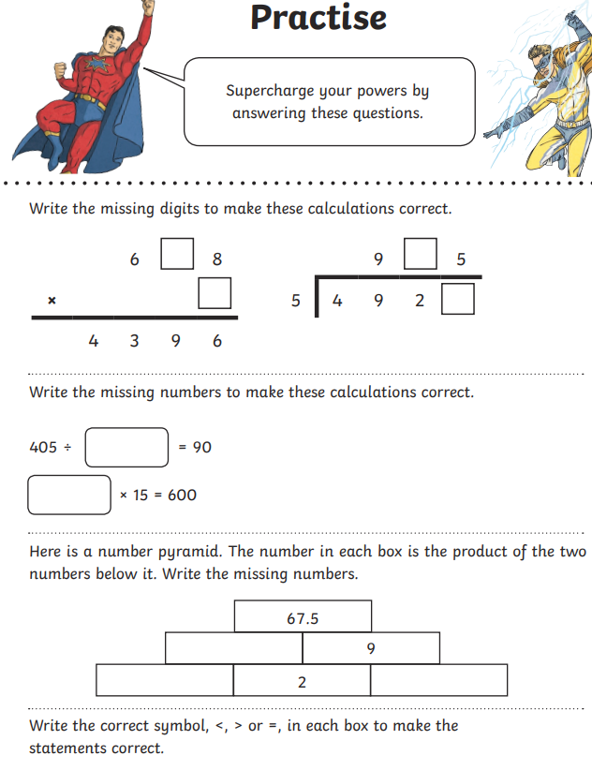
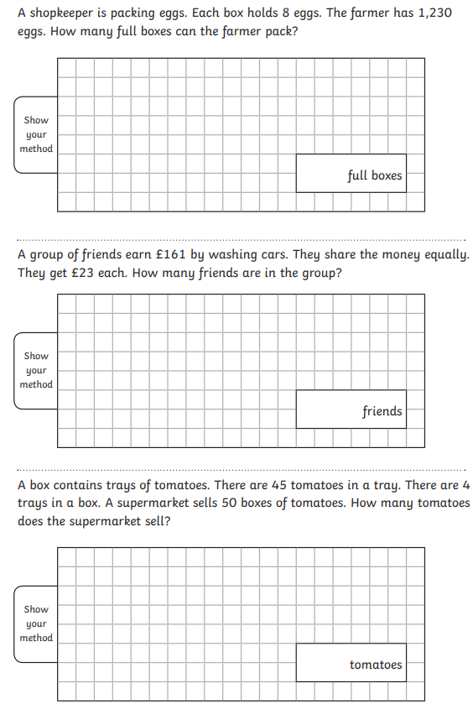
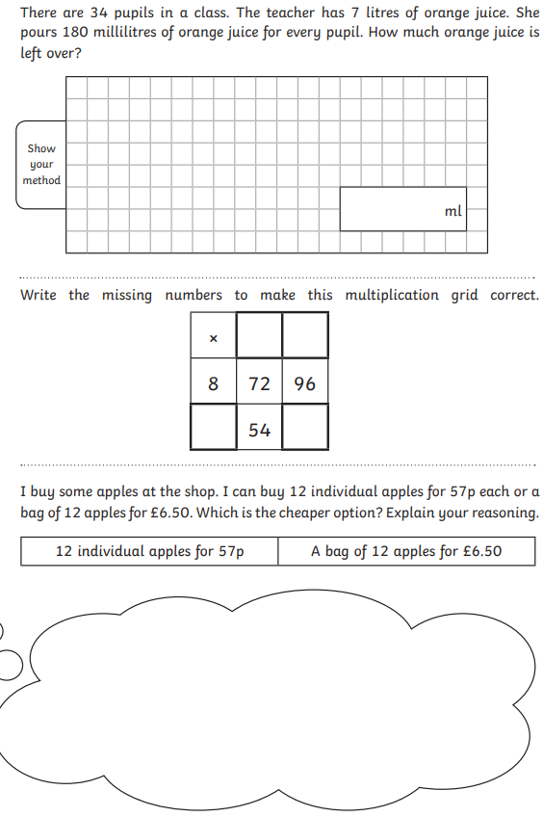
Art
Can you recreate one of these images using tone effectively? Do you recognise these landmarks?
What is a landmark?

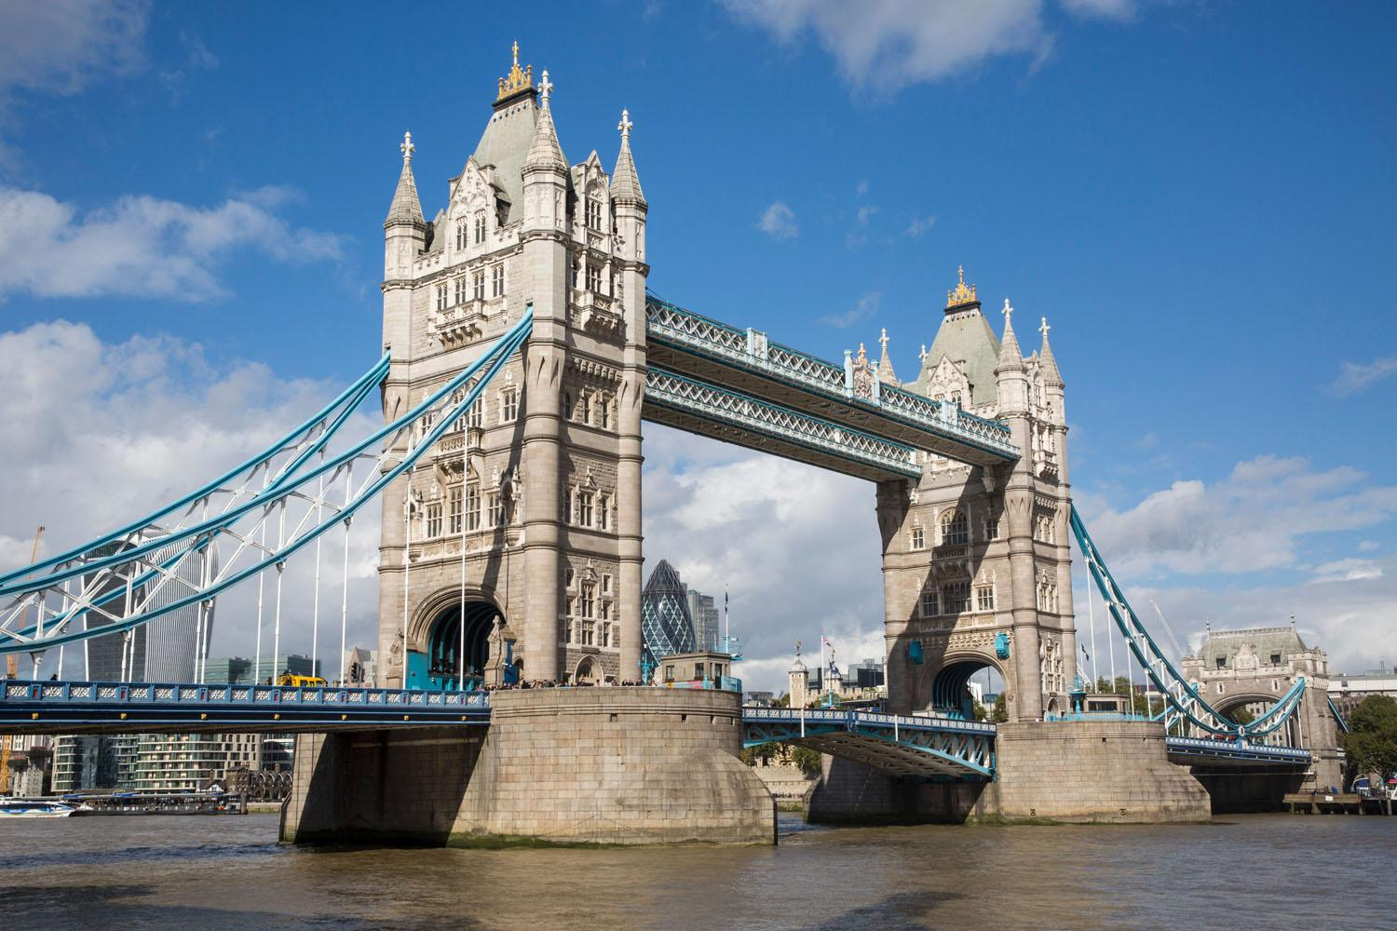

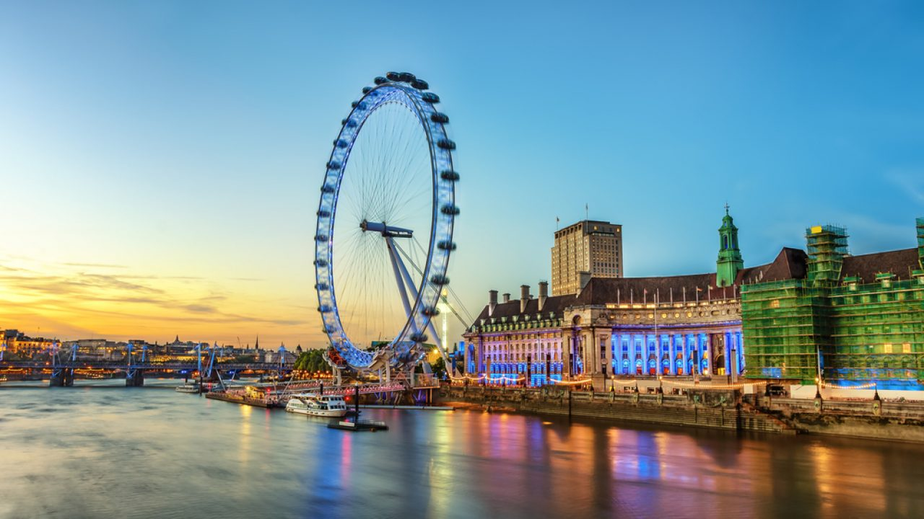

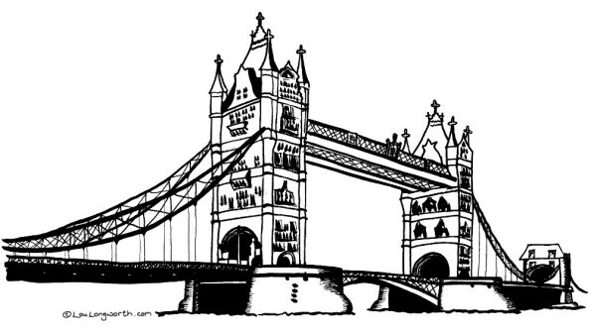

Science
The Human Body
