- In English, we watched a video called ‘Lone Robot’. Write your own story about the robot in the golden forest.
Think about: 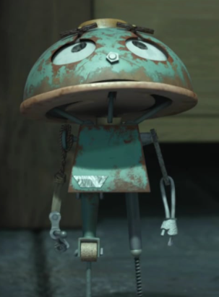
- A title for your story
- The characters. Who are they?
- How do they meet the robot? What is his name?
- Does the robot get fixed?
- What is his life like afterwards?
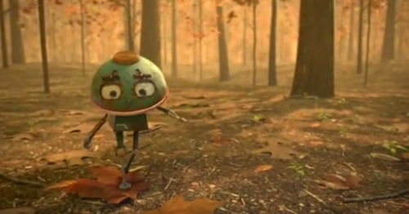
Don’t forget to make it interesting by using all the things you have learnt! (Noun phrases, descriptive language, conjunctions, prepositions and fronted adverbials).
- In Maths, we studied fractions.

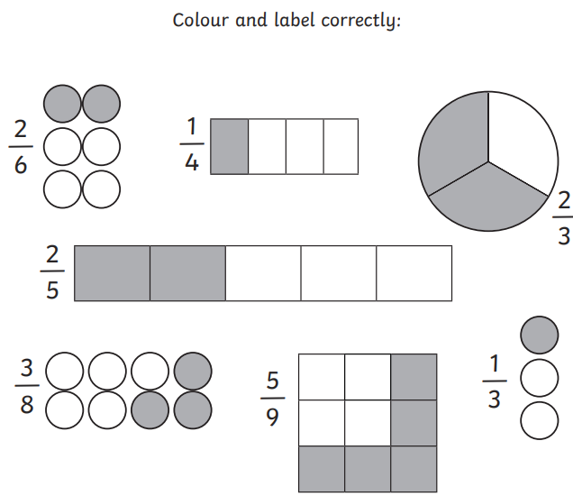
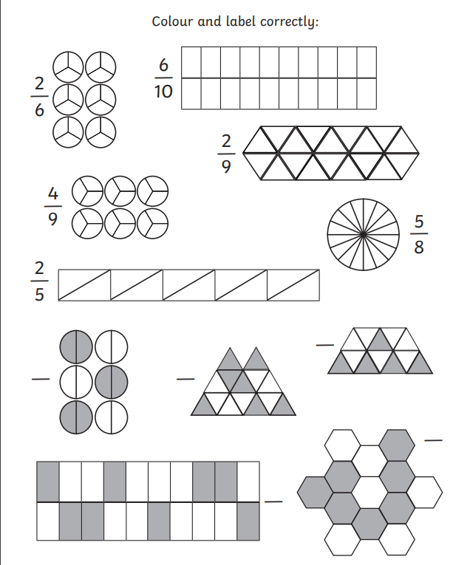

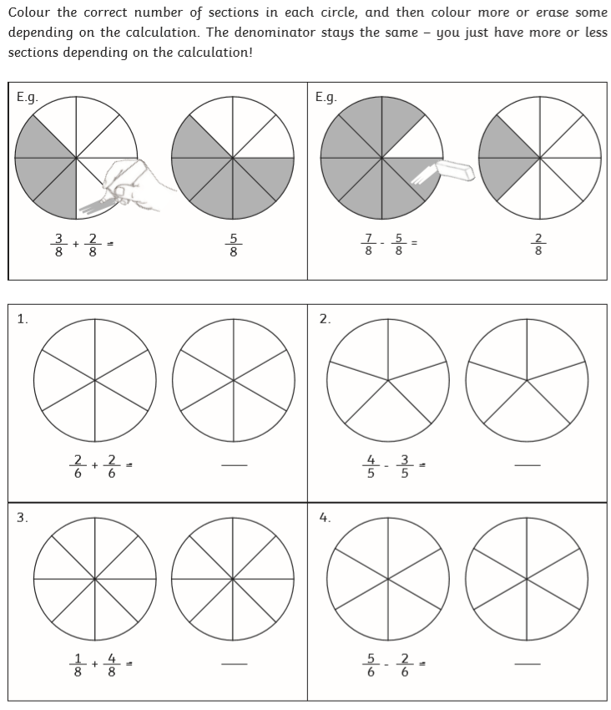

3.Spellings- write each word 10 times
humbly
gently
simply
horribly
merrily

4.Time tables

