Homework: Week 3
25th September 2020
English
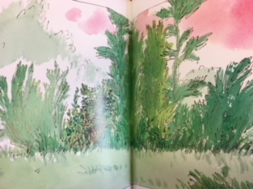
Use the pictures to help you retell the story of The Green Ship.
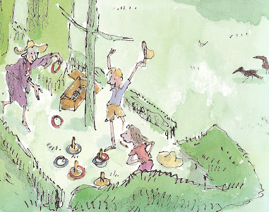
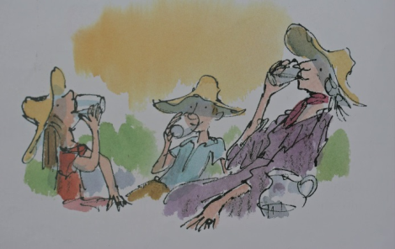
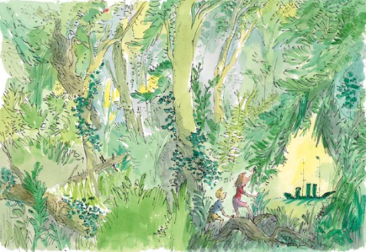
During the summer, Alice and her brother were staying at………
One day, they decided to…………….because………………
After climbing over the wall………..

In the distance……..
As Alice and her brother……………..they heard…………..

The next day…………….
Mrs Tredegar and the Bosun…………..

Spellings
 | Copy | Cover | Check
treasured
treasuring
measurement
measuring
leisurely
capturing
pictured

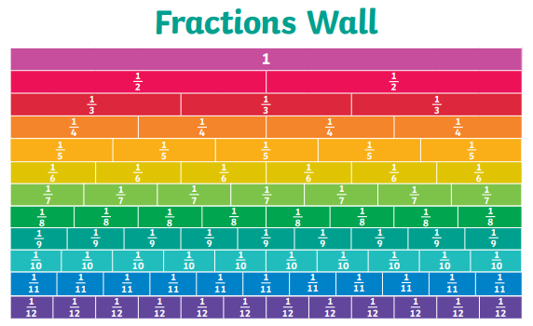
Maths
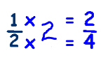
Fractions

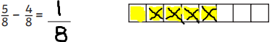
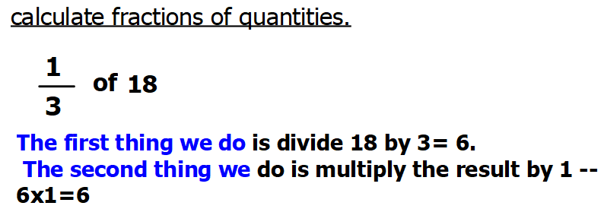
A
Use the bar method to calculate these fractions.
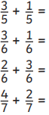 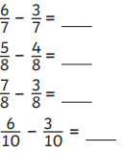 What fractions are equivalent to 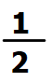?
B
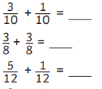
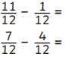
Calculate the fractions of these amounts:
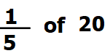
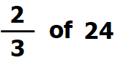
C
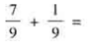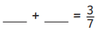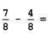
Calculate the equivalent fractions of the following:
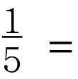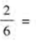
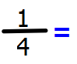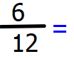
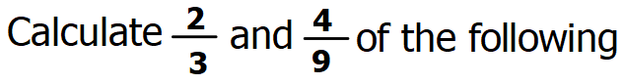27= 36=
45= 54=

Topic – PSHE
Creating a positive mind set

Scenario 1:
There is a new pupil in your class. They feel a little nervous about being new to the school and are worried they will not make any friends. What can you do to help? How would you make them feel welcome?
Scenario 2:
You and your partner have just marked your mixed times tables test. You both had the same questions, but all of your six times tables are incorrect. Your partner has got full marks. You have started to think negatively about yourself. How can you change this with a positive mind set?
Look at the scenarios above and write your responses.

