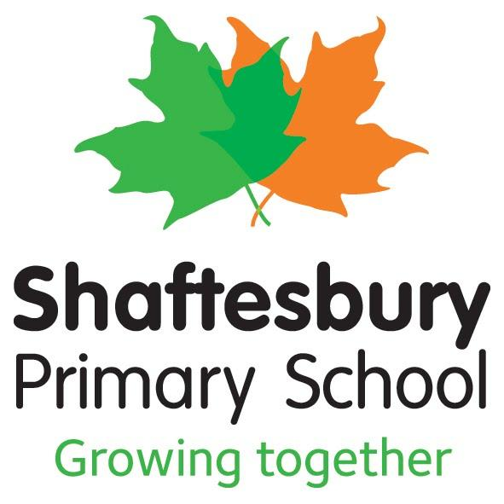
Policy title | : | Geography Policy
Date approved | : | September 2021
Review date* | : | September 2023

Introduction
Shaftesbury delivers a high quality Geography curriculum which encourages and inspires children to be inquisitive learners with regards to the natural world around them as well as the people that live in it. Teaching equips children to have a deep, long-term understanding of the Earth's key physical and human processes. Geography at Shaftesbury focuses on the local community as well as the wider global community and analyses how the physical and human aspects of both have changed over time. Geography at Shaftesbury is taught once a week (on a half termly basis) discretely from Years 1-6 but is also taught through a range of other subjects. This is through cross curricular links in subjects such as English, Maths, Computing, PSHE, History and Music. They acquire a range of geographical skills and conduct various fieldwork activities from EYFS to Year Six. Vocabulary is embedded in every geography lesson and it helps children understand and obtain a range of locational and place knowledge. Geographical skills and knowledge are also enhanced through Shaftesbury’s application for International Status award as well as obtaining the Eco School’s green flag award by the end of this academic year.
Aims and Objectives
∙ To develop contextual knowledge of the location of globally significant places – both terrestrial and marine – including their defining physical and human characteristics and how these provide a geographical context for understanding the actions of processes
∙ To understand the processes that give rise to key physical and human geographical features of the world, how these are interdependent and how they bring about spatial variation and change over time
∙ To be competent in the geographical skills needed to:
o collect, analyse and communicate with a range of data gathered through experiences of fieldwork that deepen their understanding of geographical processes
o interpret a range of sources of geographical information, including maps, diagrams, globes, aerial photographs
o communicate geographical information in a variety of ways, including through maps, numerical and quantitative skills and writing at length.

Geography Curriculum Planning
To deliver the geography curriculum effectively and in line with government requirements we follow the programmes of study which can be found and referenced in the following publications:
• Foundation stage – Early Learning Goals
• Key Stage 1 - National Curriculum
• Key Stage 2 - National Curriculum
We use the national curriculum for geography as the basis for our curriculum planning. We have tailored our curriculum to the local circumstances of our school, i.e. we make use of the local environment in our fieldwork and we also choose a locality where the human activities and physical features provide a contrast to those that predominate in our own immediate area.

Our curriculum planning is in three phases (long-term, medium-term and short-term). Our long-term plan maps the geography topics studied in each term during each key stage. The geography subject leader works this out in conjunction with SLT and in accordance with any changes in the school development policy. Teachers refer to the Geography curriculum map in order to plan any field work, homework or further cross curriculum links.
Our medium-term plans follow the bespoke scheme of work and give details of each unit of work for each term. The geography subject leader reviews these plans on a regular basis. They are put together
The medium term plans are used then by class teachers for the short term planning. Teachers within each year group work collaboratively to adapt the learning outcomes to meet the needs of their classes while still addressing the learning objectives and revising prior skills and learning to create a web of understanding within and across the geography curriculum.

Variation
We recognise the fact that there are children of widely different geographical abilities in all classes and we provide suitable learning opportunities for all children by matching the challenge of the task to the ability of the child. We achieve this by:
• setting common tasks which are open-ended and can have a variety of responses;
• providing resources of different complexity according to the ability of the child;
• using classroom assistants to support the work of individual children or groups of children.

We plan the topics in geography so that they build upon prior learning. Children of all abilities have the opportunity to develop their skills and knowledge in each unit and, through planned progression built into the scheme of work, we offer them an increasing challenge as they move up the school.
Foundation Stage
We teach geography in the Nursery and Reception classes as an integral part of the topic work covered during the year. As these classes are a part of the Foundation Stage of the National Curriculum, we relate the geographical aspects of the children’s work to the objectives set out in the Early Learning Goals (ELGs) which underpin the curriculum planning for children aged three to five. Geography makes a significant contribution to the ELG objectives of developing a child’s knowledge and understanding of the world through stories and various other activities.
Assessment
At our school we teach geography to all children, whatever their ability. Geography is a part of the school curriculum policy. This helps to provide a broad and balanced education to all children. Through our geography teaching we provide learning opportunities that enable all pupils to make progress. We do this by setting suitable learning challenges and responding to each child’s different needs. Assessment against the National Curriculum allows us to consider each child’s attainment and progress against expected levels.

We assess the children’s work in geography by making informal judgements as we observe the children during lessons. Once the children complete a piece of work, we mark and comment as necessary. This weekly recorded dialogue is essential to inform planning.

Once the children complete a unit of work in a half term, we spend a lesson reviewing the scheme using bespoke target cards. Here the children have the opportunity to self assess their learning using their mind maps that they created and built on during the scheme of work. The teacher makes a note of any targets that may not have been met on the individual’s target card and where else in the curriculum this skill or knowledge may be revisited.
The geography subject leader keeps samples of the children’s work in a portfolio which shows what the expected level of achievement is in geography in each year of the school.
Inclusion
At our school we teach geography to all children, whatever their ability. Geography forms part of the school curriculum policy to provide a broad and balanced education to all children. Through our geography teaching we provide learning opportunities that enable all pupils to make progress. We do this by setting suitable learning challenges and responding to each child’s different needs. Assessment against the National Curriculum allows us to consider each child’s attainment and progress against expected standards. When progress falls significantly outside the expected range, the child may have special educational needs. Our assessment process looks at a range of factors – classroom organisation, teaching materials, teaching style, variation – so that we can take some additional or different action to enable the child to learn more effectively. This ensures that our teaching is matched to the child’s needs. Intervention through SEN Support and EHC plans will lead to the creation of an Individual Education Plan (IEP) for children with special educational needs. The IEP may include, as appropriate, specific targets relating to geography. As well as this we have a tailored curriculum aimed at our SEN children who do not meet pre key stage standards.

Resources
We have sufficient resources in our school to be able to teach all the geography topics. We have a wide range of globes available and a range of age appropriate atlases in each year group. From year 3, the pupils learn to use Digimaps – a digital mapping tool to develop skills in OS map use and research. We also use the online platform of Oddizzi which is dedicated to geography. Children can access this at home and teacher use it as an additional resource to plan from. Shaftesbury also has a diverse community, so on occasion children will be encouraged to celebrate the international diversity of our school through ‘International Week’ or through celebrating the European Day of Languages among other events. We believe that nothing can replace real-life experiences and as such we promote learning outside the classroom as much as possible.

Roles and responsibilities
The Geography Coordinator is responsible for:
• Enhancing the quality of Geography teaching through training and management of the curriculum.
• Monitoring and supporting planning and evaluation of Geography lessons. • Developing and supporting the assessment of children in geographical skills. • Ordering and maintaining resources.
• Ensure and support teachers in their use of computing to support and enhance the children’s learning of geography.
• To ensure that geography topics reflect the global dimensions of our community.
The class teachers are responsible for:
• Planning and implementing the geography schemes of work.
• Collecting, organising and evaluating resources for geography lessons. • Assessment of children’s geographical ability.
• Ensuring the quality of geography teaching in their lessons is in line with the geography policy.
• Ensure that geography learning and skills are reflected in displays throughout the school.
Equal Opportunities
We ensure that all children have full access to the curriculum and that all resources, teaching methods and topics reflect the cultural diversity of the school and local communities.
All children and staff will know that their own traditions and cultural identities are valued and embraced. All teaching in geography will be in accordance with the Shaftesbury’s Equality Policy.

